STUDENT ASSESSMENT SUBMISSION AND DECLARATION
Student Name: MN. Sihanas / 1030371 |  | Assessor Name: Mr. M.I. Mohamed Nismy
Issued Date: | Submission Date: 2024.05.30 |  | Submitted On: 2024.08.22
Program: Networking

Unit: 02

Assignment number and title:

Plagiarism
Plagiarism is a particular form of cheating. Plagiarism must be avoided at all costs and students who break the rules, however innocently, may be penalized. It is your responsibility to ensure that you understand correct referencing practices. As a university-level student, you are expected to use appropriate references throughout and keep carefully detailed notes of all your sources of materials for material you have used in your work, including any material downloaded from the Internet. Please consult the relevant unit lecturer or your course tutor if you need any further advice.
Student Declaration
Student Declaration

I certify that the assignment submission is entirely my own work and I fully understand the consequences of plagiarism. I understand that making a false declaration is a form of malpractice.

Student Signature: 1030371@bcas.ac Date:2024.05.30

ASSESSMENT TRACKING
ASSESSMENT RECORD AND FEEDBACK SHEET
Program: | HND in Computing | Student Name: | MN. Sihanas | Unit Grade:
Unit No. & Title: | 02: Networking | Year: | 2023/2024 | Assessment Date:
Assessor Name: | Mr. M.I. Mohamed Nismy | Unit Completion Date: |  | IV Signature: | jubailah@bcas.lk

Activity No | Learning Objectives | Criteria Targeted | Date Issued | Hand In Date | Formative  Feedback | Resubmission Date*
 | LO1  LO2 | P1  P2  P3  P4  M1 | 08.05.2024 | 18.05.2024
 | LO2  LO3 | P5  P6  M2  M3 | 08.05.2024 | 25.05.2024
 | LO2  LO3  LO4 | P7  P8  M4 | 08.05.2024 | 15.06.2024
 | LO1  LO2  LO3  LO4 | D1  D2 | 08.05.2024 | 07.06.2024
* Resubmissions must be approved by the Assessment Board

Unit 02: Networking
Assignment Brief
Student Name/ID Number | MN.Sihanas / 1030371
Unit Number and Title | Unit 02: Networking
Academic Year | 2023/2024
Batch / Cohort & Semester | Batch 22, Semester 1
Unit Tutor | Mr. M.I. Mohamed Nismy
Assignment Title | NetWiz Solutions
Issue Date | 08.05.2024
Submission Date | 24.07.2024
Submission Format
Activity 01
A written report

Activity 02
An implementation plan to design a networked system and maintenance schedule for the specified scenario. The report should also include a discussion of a range of server types and a justification of the final selection, along with a test plan and an analysis of user feedback.
The recommended word limit is 1,000–1,500 words, although you will not be penalized for exceeding the total word limit.
You are required to make use of headings, paragraphs, and subsections as appropriate, and all work must be supported with research and referenced using the Harvard referencing system.

Activity 03
A technical report to demonstrate the implementation of the designs for a networked system. The test plan created in the design should also be carried out and the test results recorded.
The recommended word limit is 1,500–2,000 words, although you will not be penalized for exceeding the total word limit.
You are required to make use of headings, paragraphs, and subsections as appropriate, and all work must be supported with research and referenced using the Harvard referencing system.

Activity 04
A written report to evaluate the topology selected for the development of the networked system, as well as an evaluation of the implemented network.
The recommended word limit is 1,000–1,500 words, although you will not be penalized for exceeding the total word limit.
You are required to make use of headings, paragraphs, and subsections as appropriate, and all work must be supported with research and referenced using the Harvard referencing system.
Unit Learning Outcomes
LO1 Examine networking principles and their protocols
LO2 Explain networking devices and operations
LO3 Design efficient networked systems
LO4 Implement and diagnose networked systems
Transferable skills and competencies developed
Students should be able to
- Analyze a network system
- Design a network system.
- Design a test-cases to test a network system.
- Do subnetting.
- Use network simulation tools such as CISCO Packet Tracer or GNS3.
- Analytical Skills.
- Critical thinking
Vocational scenario
NetWiz Solutions is a leading IT solution provider currently situated in one office building containing three departments, namely Marketing, IT Support, and Administration. The company has 58 computers and has decided to divide the network into three subnets. The company has decided to implement a new network infrastructure that will connect all the departments and allow seamless communication and the sharing of resources.
Departments | Networking Devices (Servers, Computers and Printers)
Marketing | 20
IT Support | 12
Administration | 26

The company requires appropriate subnetworks. A Local Area Network (LAN) for each department to share specific Hardware and Software resources. The network should be designed to ensure efficient communication and minimal latency.
As you are a newly joined Junior Network Administrator at NetWiz Solutions, the Chief Executive Officer (CEO) and Senior Network Administrator have asked you to design and build a virtual network solution that will fulfill the company's requirements. This will help the company identify any potential issues in the requirements before spending money on reorganizing the network layout and employee requirements.
In addition, the company wants you to prepare a report for them, showing the range of available networking topologies, protocols, hardware, and software, to prove that you have the breadth of knowledge available to you before you begin the design task.
Assignment activity and guidance
Activity 1
Produce a well-prepared report for the CEO and Senior Network Administrator of NetWiz Solutions that explains the core principles of networks and networking protocols. The report will also include a discussion of the range of network hardware and software available to the systems developer.
Your report should include:
- A discussion of the benefits and constraints of different network types, e.g. wired, wireless, hybrid
- A discussion of the benefits and constraints of different network standards, e.g. OSI, TCP/IP, 802. x
- An explanation of the impact of network topology, communication, and bandwidth requirements, identifying the advantages and disadvantages of each to a network design
- An assessment of common networking principles and how network protocols, e.g. IPv4, IPv6, HTTPS, can enable an effective networked system.
- A discussion of the operating principles of networking devices and network server types, e.g. routers, switches, firewalls, repeaters, bridges, IoT gateways, domain, web, file, and database servers, access permissions
- A discussion of how workstation hardware and the relevant networking software depend on each other.

Activity 2
You are required to design a networked solution for the requirements specified by NetWiz Solutions. You should make use of whichever design tools and techniques are most appropriate for your network and the nature of the networked solution. You should produce your evidence as an implementation plan.
Your implementation plan should include the following.
- The design of the network, including any networking hardware, software, network addresses, devices, and users, including any network sub-domains as well as the physical location of these devices within the organization
- Any device configuration and security considerations should be included, and an IPv4 address should be selected on your own for this purpose.
- The design of a maintenance schedule to support the networked system.
- A test plan covering all areas of the networked system requirements, indicating the test action, test data, and expected results
- Feedback from a range of users on the effectiveness of the solution design
- An analysis of the user feedback to optimize the design and improve the efficiency of the networked solution
- A clear explanation of how the network designs have been optimized and improved
- An explanation of the range of network server types available required by the NetWiz Solutions scenario and a recommended selection
- A justification of the recommended server selection, with a specific focus on cost and performance optimization.

Activity 3
You are required to implement a virtual networked solution for the requirements specified by NetWiz Solutions. You should make use of whichever virtual network simulator is most appropriate for your optimized network design and the nature of the networked solution. You should produce your evidence as a technical report.
Your report should include:
- Clear evidence for the implementation of the optimized design, for example, screenshots, configuration files, annotated and verified demonstration evidence, network monitoring reports
- A test plan implementation, using the test plan designed in Activity 2, clearly documenting the test results against the expected results
- An analysis of the results of the test plan and, based on this, recommendations of potential enhancements for the networked system.

Activity 4
Write an evaluative report for the CEO and Senior Network Administrator of NetWiz Solutions that provides a reflective overview of the selected topology as well as the network design and implementation.
Your report should include:
- An evaluation of network topology and any protocols selected for the given scenario.
- An evaluation of how the topology and protocols demonstrate the efficient use of a networking system
- A critical reflection on the final implemented network and design
- A critical reflection of the decisions made to enhance the network design and the implemented solution.
Recommended Resources
Please note that the resources listed are examples for you to use as a starting point in your research – the list is not definitive.
Textbooks
Burgess, M. (2003) Principles of Network and System Administration. 2nd edn. John Wiley and Sons Ltd.
Donahue, G. A. (2011) Network Warrior 2nd edn. O’Reilly Media.
Goransson, P. Black, C. et al (2016) Software Defined Networks: A Comprehensive Approach 2nd edn. Morgan Kaufmann.
Hallberg, B. (2005) Networking: A Beginner’s Guide. 4th edn. Osborne/McGraw-Hill US.
Limoncelli, T. and Hogan, C. (2001) The Practice of System and Network Administration. Addison-Wesley.
Lowe, D. (2005) Networking All-in-One Desk Reference for Dummies. 2nd edn. Hungry Minds Inc.
Olifer, N. and Olifer, V. (2005) Computer Networks: Principles, Technologies and Protocols for Network Design. John Wiley and Sons Ltd.
Stallings, W. (2003) Data and Computer Communications. 7th edn. (Prentice Hall).
Tanenbaum, A. (2002) Computer Networks. Prentice Hall PTR.

Learning Outcomes and Assessment Criteria
Pass | Merit | Distinction
LO1 Examine networking principles and their protocols
P1 Discuss the benefits and constraints of different network types and standards.  P2 Explain the impact of  network topology, communication, and bandwidth requirements. | M1 Assess common networking principles and how protocols enable the effectiveness of networked systems. | LO1 & LO2  D1 Evaluate the topology protocol selected for a given scenario and how it demonstrates the efficient utilization of a networking system.
LO2 Explain networking devices and operations
P3 Discuss the operating principles of networking devices and server types.  P4 Discuss the interdependence of workstation hardware and relevant networking software. | M2 Explore a range of server types and justify the selection of a server for a given scenario, regarding cost and performance optimization.

Pass | Merit | Distinction
LO3 Design efficient networked systems
P5 Design a networked system to meet a given specification.  P6 Design a maintenance schedule to support the networked system. | M3 Analyse user feedback on your designs to optimize your design and improve efficiency. | LO3 & LO4  D2 Critically reflect on the implemented network, including the design and decisions made to enhance the system.
LO4 Implement and diagnose networked systems.
P7 Implement a networked system based on a prepared design.  P8 Document and analyze test results against expected results. | M4 Recommend potential enhancements for the networked systems.

Guidance for Students

Deliverable: Report Should be submitted one soft copy of word-processed Report.

NOTE:
- You should include the COVER PAGE, Assessment Declaration form and Unit Review Plan of this assignment when you submit your final report.

- If submitted after the extended deadline, the assignment will not be accepted whereas you shall be asked to go for a NEW assignment.

- Late Submission is not permitted until otherwise recommended by the Assessor /Course Coordinator.
- Plagiarism will be treated as a very Serious academic misconduct.

Instructions to students:

- All assignment should comprise of the standard Front Cover given. No other front page will be accepted.

- Report Writing Guidelines:

  - Every Assignment should have an Introduction and Conclusion.
  - The standard Table of Contents should be generated.
  - All the Figures, Tables, Diagram etc. should be numbered.
  - Main Heading Font: Arial; Size 16
  - Sub heading: Font: Arial; Size 14
  - Body text: Font: Arial; Size 11
  - Paragraph: 1.5 spacing
  - Margins: Top: 1” Bottom: 1” Left: 1” Right: 1”
  - Header – include the module name on the right hand side
  - Footer – include the page number on the right hand side
  - All sections should have continuity and pages should be clearly ladled.
References – clear references for all the materials, books, articles, website etc should be given in accordance with Harvard Reference style (Harvard Anglia 2008
Acknowledgement

I would like to express my sincere gratitude to Mr. M.I. Mohamed Nismy, Lecturer at British College of Applied Studies Campus, and Mr. Mohamed Ishraque, Head of British College of Applied Studies Campus Kalmunai Branch, for giving me the chance to work on and finish the networking assignment. The outstanding support, counsel, and direction I received from Mr. Nismy was essential to finishing my thesis successfully. We could not have completed this project without his help and knowledge.
I also want to express my gratitude to each and every lecturer in the British College of Applied Studies Campus's HND programme for their valuable knowledge and assistance with the thesis. Furthermore, I would like to express my gratitude to all of the instructors at British College of Applied Studies Campus who helped me, either directly or indirectly, with my work.
Finally, I would like to express my sincere gratitude to my family and fellow students for their steadfast support throughout the assignment period. Their support and encouragement helped me overcome obstacles and successfully finish this project.

I sincerely appreciate all of your help and contributions.
Abstract

In order to build effective and efficient network systems at NetWiz Solutions, a thorough understanding of networking protocols and principles is presented in this report. The fundamentals of networking are explained, including the different kinds, standards, and topologies of networks. The advantages and disadvantages of wired, wireless, and hybrid networks are examined, emphasising how important it is to choose the right kind for a given organization's needs.

Examining well-known network standards like OSI, TCP/IP, and IEEE 802.x, the paper assesses the benefits and drawbacks of each for network architecture and deployment. It also discusses the effects of communication protocols, bandwidth requirements, and network topology, offering insights into the benefits and drawbacks of various network configurations.
A thorough analysis of networking principles is given, with a focus on how secure and effective network operations are made possible by protocols like IPv4, IPv6, and HTTPS. Along with a discussion of the different types of network servers domain, web, file, and database servers the working principles of important networking devices such as routers, switches, firewalls, and Internet of Things gateways are also covered.

The report also looks at how networking software and workstation hardware are interdependent, highlighting how important it is to have a well-maintained network infrastructure. With the help of useful suggestions for improving network architecture and performance, NetWiz Solutions will be able to create network systems that are reliable, scalable, and secure.

In order to maximise NetWiz Solutions' planned network deployment and support the company's technological advancement and operational efficiency, the report ends with strategic recommendations.

Contents
Introduction 1
Activity 1 2
1.1 Types of Computer Network 2
1.1.1. LAN (Local Area Network) 2
1.1.2. MAN (Metropolitan Area Network) 3
1.1.3. WAN (Wide Area Network) 4
1.1.4. PAN (Personal Area Network) 5
1.2. Types of network standards and models 6
1.2.1. IEEE standards 6
1.2.2. OSI model 8
1.2.3. TCP/IP model 12
OSI vs TCP/IP 14
1.3. Network topology 15
1.3.1. Bus topology 15
1.3.2. Ring topology 16
1.3.3. Star topology 17
1.3.4. Mesh topology 18
1.3.5. Tree topology 19
1.4. bandwidth 21
Important of bandwidth 21
Considerations for calculating required bandwidth 22
1.5. Network devices 23
1.5.1. Repeater 23
1.5.2. Hub 23
1.5.3. Bridge 24
1.5.4. Switch 24
1.5.5. Routers 26
1.5.6. Gateway 27
1.5.7. Firewall 27
1.5.8. Modem 28
1.5.9. WAP (Wireless Access Point) 28
1.6. Server types 29
1.6.1. Web server 29
1.6.2. Mail server 29
1.6.3. Application server 30
1.6.4. Database server 30
1.6.5. DNS server 30
1.6.6. Proxy server 31
1.6.7. DHCP server 31
1.6.8. File server 31
1.6.9. Gaming server 31
1.6.10. Print server 32
1.7. Interdependence between workstation hardware and networking software 32
Activity 2 34
2.1. Network Design 34
2.1.1. IP Addressing Scheme: 34
2.1.2. VLAN Configuration: 34
2.1.3. IP Address Allocation Table 35
2.1.4. Visual design for the network 35
2.2. Networking Hardware 36
2.3. VLAN Setup 36
2.4. Network Address and Device Connections 37
2.5. Physical location within the organization 37
Room 1 37
Room 2 37
Room 3 37
2.6. Security Consideration 37
2.7. Network maintenance schedule 38
2.8. Test plan for the networked system 40
Activity 3 41
3.1. Implementation of the optimized design for the network 41
3.1.1. Network Design and Initial Setup 41
3.1.2. Router Configuration 42
3.1.3. VLAN isolation configuration 43
3.1.4. DHCP Configurations 44
3.1.5. VLAN Configuration 44
3.1.6. Trunk configurations 45
3.1.7. Switchport configurations 46
3.1.8. IP Address Assignment 49
3.1.9. Checking briefs on CLI 50
3.2. test plan implementation and actual results 51
1. VLAN Configuration 51
2. Trunking Between Switches 53
3. DHCP Configuration 54
4. Default Gateway Configuration 57
5. Network Security (VLAN Isolation) 58
3.3. Analysis of the test results and recommendations 60
3.3.1. Analyze the Test Results 60
3.3.2. Recommendations for Potential Enhancements 61
Conclusion 63

Table 1 Advantages and disadvantages of LAN (sonalchindage, 2023) 3
Table 2:Advantages and disadvantages of MAN (sonalchindage, 2023) 4
Table 3: advantages and disadvantages of WAN (sonalchindage, 2023) 5
Table 4: advantages and disadvantages of PAN (sonalchindage, 2023) 6
Table 5: IEEE standard and usage (Gaurav, 2024) 8
Table 6:advantages and disadvantages of OSI model (Kara Gattine, 2021) 11
Table 7:advantages and disadvantages of TCP/IP (Kinza Yasar, 2024) 13
Table 8:similarities and differences between OSI and TCP/IP (Kinza Yasar, 2024) 15
Table 9: Advantages and disadvantages of bus topology (Pedamkar, 2023) 16
Table 10:advantages and disadvantages of ring topology (Pedamkar, 2023) 17
Table 11: advantages and disadvantages of star topology (Pedamkar, 2023) 18
Table 12:advantages and disadvantages of mesh topology (Pedamkar, 2023) 19
Table 13: advantages and disadvantages of tree topology (Pedamkar, 2023) 20
Table 14: topologies and their applications (Pedamkar, 2023) 21
Table 15:IP and VLAN allocation 35
Table 16: maintenance schedule for the network 38
Table 17: test plan for the networked system 40
Table 18:actual results of test 1 53
Table 19:actual results of test 2 54

Figure 1 (Mikac, 2023) 2
Figure 2: (Wright, 2024) 3
Figure 3 (Scarpati, 2023) 4
Figure 4 (Yasar, 2022) 5
Figure 5 (Kara Gattine, 2021) 9
Figure 6 (Kinza Yasar, 2024) 12
Figure 7 (Kinza Yasar, 2024) 14
Figure 8 (Pedamkar, 2023) 15
Figure 9 (Pedamkar, 2023) 16
Figure 10 (Pedamkar, 2023) 17
Figure 11 (Pedamkar, 2023) 18
Figure 12 (Pedamkar, 2023) 19
Figure 13 (Andrew Froehlich, 2021) 22
Figure 14 (Kanade, 2023) 29
Figure 15:Visual design of the network 36
Figure 16: implemented design in cisco packet tracer 42
Figure 17:Default gateway IP address for marketing switch 43
Figure 18:Default gateway IP address for IT_Support 43
Figure 19:Default gateway IP address for administration 43
Figure 20:Excluding default gateway addresses before creating DHCP pools 43
Figure 21:EXcluding IP addresses for printers and servers 44
Figure 22:creating ACLs 44
Figure 23:Applying ACLs 44
Figure 24:DHCP pool for VLAN 10 45
Figure 25:DHCP pool for VLAN 20 45
Figure 26:DHCP pool for VLAN 30 45
Figure 27:Creating VLAN 10 and giving VLAN 10 access 45
Figure 28:Creating VLAN 20 and giving VLAN 20 access 46
Figure 29:Creating VLAN 30 and giving VLAN 30 access 46
Figure 30:Configuring trunk in administration switch 1 46
Figure 31:Configuring trunk in administration switch 2 47
Figure 32:Creating VLAN 10 access to the interfaces in marketing switch 47
Figure 33:Creating VLAN 20 access to the interfaces in IT_Support switch 48
Figure 34:Creating VLAN 30 access to the interfaces in administration switch 1 48
Figure 35:Creating VLAN 30 access to the interfaces in administration switch 2 49
Figure 36:assign DHCP IP to the end devices 50
Figure 37:assigning static IP address for the server in VLAN 10 50
Figure 38:IP routing brief 51
Figure 39:DHCP pool brief 51
Figure 40:IP interface brief (router) 52
Figure 41:vlan brief of marketing switch 52
Figure 42:vlan brief of IT_Support switch 53
Figure 43:vlan brief of administration switch 1 53
Figure 44:vlan brief of administration switch 2 53
Figure 45: trunk interface brief of administration brief 1 54
Figure 46:trunk interface brief of administration switch 2 54
Figure 47:setting DHCP IP to a PC in VLAN 10 55
Figure 48:setting DHCP IP to a PC in VLAN 20 56
Figure 49:setting DHCP IP to a PC in VLAN 30 57
Figure 50:Ping VLAN 10 default gateway with the VLAN 10 PC 58
Figure 51:Ping VLAN 20 default gateway with the VLAN 20 PC 58
Figure 52:Ping VLAN 30 default gateway with the VLAN 30 PC 59
Figure 53:Ping from vlan 10 device to VLAN 20 device 59
Figure 54:Ping from vlan 10 device to VLAN 30 device 60
Figure 55:Ping from vlan 20 device to VLAN 30 device 60

Introduction
Networking is a fundamental aspect of modern information technology, enabling communication and resource sharing among devices. This report, prepared for the CEO and Senior Network Administrator of NetWiz Solutions, provides a detailed analysis of core networking principles and protocols. It covers various network types, standards, topologies, communication and bandwidth requirements, networking principles, and protocols. Additionally, the report discusses networking devices, server types, and the relationship between workstation hardware and networking software. The goal is to provide a comprehensive understanding to guide the planning and implementation of an efficient network infrastructure for NetWiz Solutions.

Activity 1

1.1 Types of Computer Network
Computer networks can be categorized based on the geographical spread of the connected computers.
There are 4 main types:
- LAN (Local Area Network)
- MAN (Metropolitan Area Network)
- WAN (Wide Area Network)
- PAN (Personal Area Network)

LAN (Local Area Network)
A Local Area Network (LAN) is a collection of devices located in the same physical area, such as a home, office, or coffee shop, that are interconnected and capable of communication. (Gough, 2024)
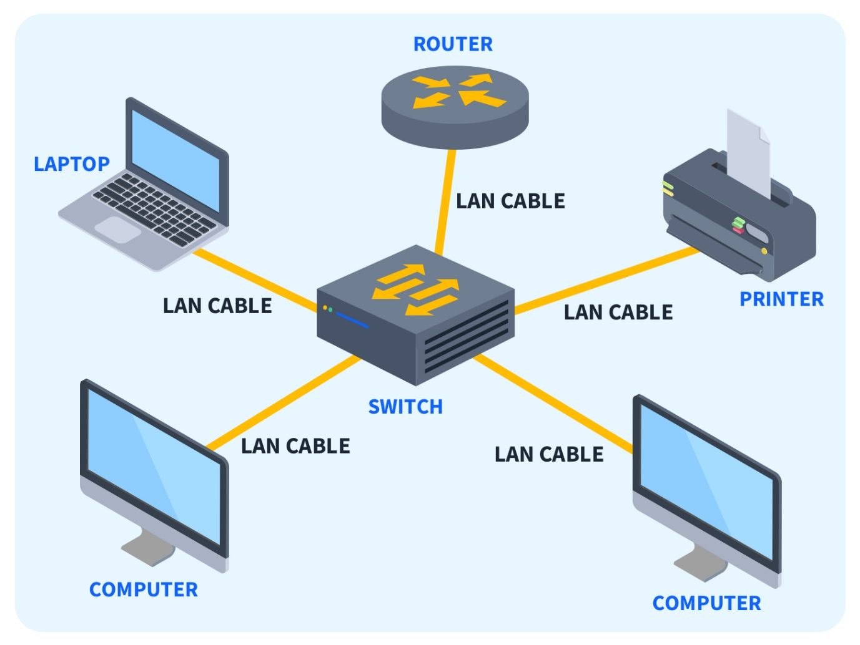
Figure 1 (Mikac, 2023)

Advantages | Disadvantages
Immediate and easy to set up | It is difficult and time-consuming to send files from outside the network
single licensed program that can be used by any device on a network | If central server fails, the entire network can go down.
communicate directly at very high speed | require regular maintenance and management to ensure optimal performance
 | As the number of devices increases, the network can become slow and congested
Table 1 Advantages and disadvantages of LAN (sonalchindage, 2023)

MAN (Metropolitan Area Network)
A metropolitan area network (MAN) is a computer network that spans a larger area than a LAN but is confined to a single city or region. It essentially connects multiple LANs using high-speed connections, often fiber optic cables. MANs can also refer to public network infrastructure within a city or region. (Wright, 2024)
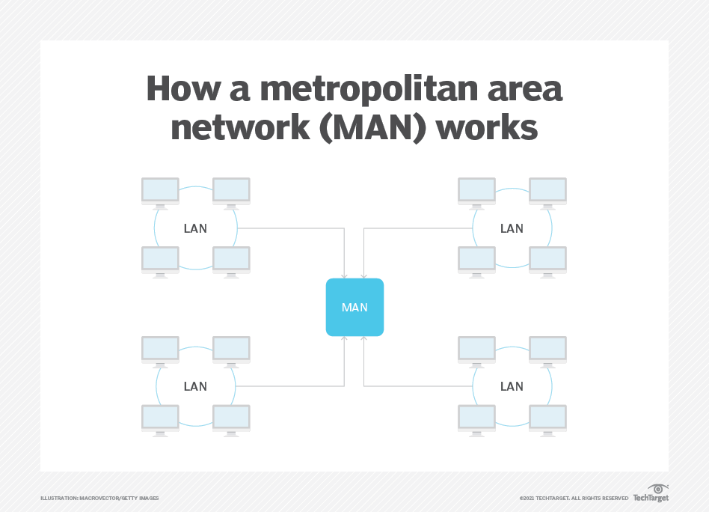
Figure 2: (Wright, 2024)
Advantages | Disadvantages
MAN is occupied more distance as compared to LAN | more cables are required to connect MAN from one place to another. MAN requires fiber optics cables which are quite expensive.
MANs can be centrally managed, making it easier to monitor and control network traffic | skilled technicians and administrators are required. This can overall increase the installation cost.
easily scaled up or down to meet changing business needs. | It is difficult to secure the system from hackers because of the large area
Compared to WANs, MANs are more cost-effective to implement and maintain.
Table 2:Advantages and disadvantages of MAN (sonalchindage, 2023)

WAN (Wide Area Network)
A Wide Area Network (WAN) is a vast interconnected system of telecommunication networks spread across large geographical regions, even countries or continents. This network enables the exchange of data among the connected networks within its boundaries. (BasuMallick, 2022)
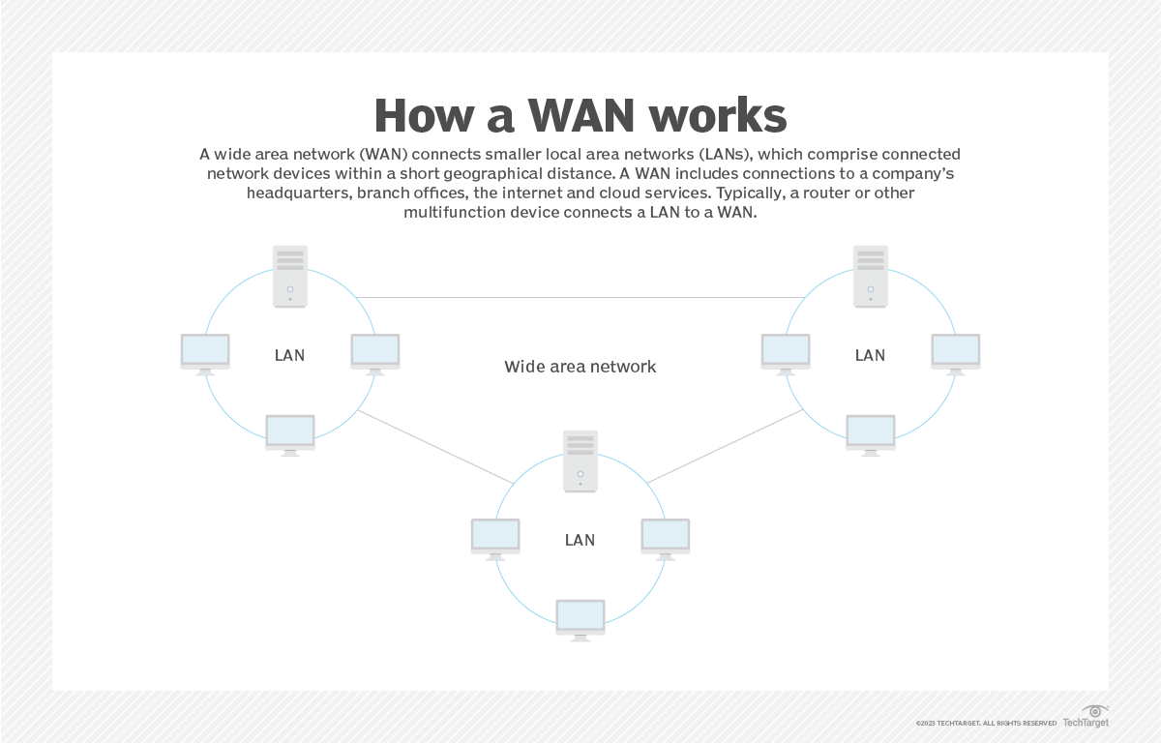
Figure 3 (Scarpati, 2023)
Advantages | Disadvantages
covers a large geographical area (1000 km or more) | WAN faces more security problems than LAN and MAN networks due to WAN networks more technologies are merged
wide area network has higher bandwidth than LAN and MAN networks. | Troubleshoot the big challenge on the WAN network and it requires more time
Using the WAN network users can share the data connected to all the devices in the respective network | it is difficult to maintain the network especially a data center that operates 24/7 is the biggest challenge out of all
Table 3: advantages and disadvantages of WAN (sonalchindage, 2023)

PAN (Personal Area Network)
A Personal Area Network (PAN) connects electronic devices within a close proximity to a single person, typically within a radius of about 10 meters. This network facilitates communication and resource sharing among devices like laptops, smartphones, and printers in small office or home environments. PANs often utilize wireless technology but can also operate with wired connections. They can also connect to larger networks like the internet. (Yasar, 2022)

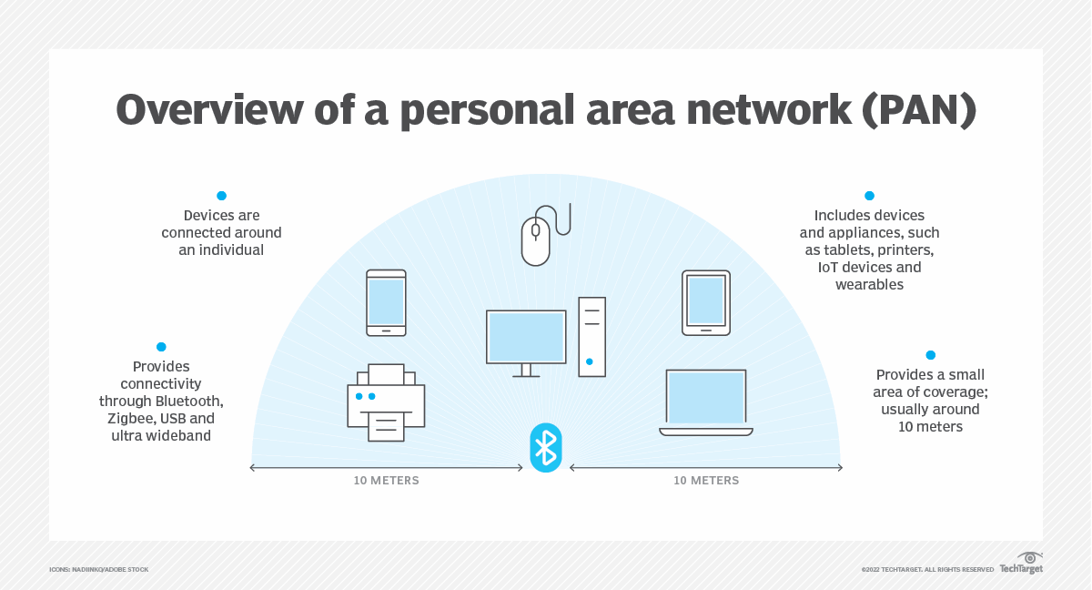
Figure 4 (Yasar, 2022)

Advantages | Disadvantages
No wires are required. | Short network range and slow data transfer
provides extreme portability | Line of sight propagation.
provides easy data synchronization between different devices. | The Bluetooth and IrDA rays used for transmission in a PAN can cause interference with radio signals
PAN network ensures a reliable and stable connection if it's established within the 10-meter range.
Table 4: advantages and disadvantages of PAN (sonalchindage, 2023)

Suitable network type for the NetWiz Solution is LAN. Because, we going to create a network withing a building. Local Area Network is best for this.

1.2. Types of network standards and models
These standards are crucial for fostering a competitive global market for product manufacturers by establishing and maintaining open systems. They ensure seamless data, information, and telecommunication technology compatibility on both national and international levels. By providing guidelines to manufacturers, vendors, government bodies, and service providers, these standards facilitate the necessary interconnectivity demanded by today's global marketplace and international communication.

There are 3 main standards:
- IEEE standards
- OSI model
- TCP/IP model

1.2.1. IEEE standards
The Institute of Electrical and Electronics Engineers (IEEE) is a global organization dedicated to advancing technology for the betterment of humanity. Composed of scientists, engineers, and students, IEEE develops standards for the electronics and computer industries. A primary goal of IEEE is to promote technological innovation.

IEEE standards for computer networks facilitate communication between diverse devices. They establish guidelines and practices for internet and related technologies to ensure smooth operation and interoperability among networking devices.

To address the challenge of communication between different computer system manufacturers, IEEE initiated Project 802 in 1985. This project divided the data link layer into Logical Link Control (LLC) and Media Access Control (MAC) sublayers.

IEEE 802 encompasses a set of networking standards that cover data link and physical layer technologies, including ethernet and wireless communications. While there are numerous IEEE standards in computer networks, we will focus on three prominent ones in the following sections. (Gaurav, 2024)

- IEEE 802: The IEEE 802 deals with the standards of LAN and MAN, i.e., Local Area Network and Metropolitan Area Network.

- IEEE 802.1: The IEEE 802.1 deals with the standards of LAN and MAN. Along with that, it also deals with the MAC (Media Access Control) bridging.

- IEEE 802.2: The IEEE 802.2 deals with the LLC (Logical Link Control). (Gaurav, 2024)

Let us look at the various IEEE standards in computer networks and their usage or function:

IEEE standards in computer networks | Description
IEEE 802 | It is used for the overview and architecture of LAN/MAN.
IEEE 802.1 | It is used for bridging and management of LAN/MAN.
IEEE 802.1s | It is used in multiple spanning trees.
IEEE 802.1 w | It is used for rapid reconfiguration of spanning trees.
IEEE 802.1x | It is used for network access control of ports.
IEEE 802.2 | It is used in Logical Link Control (LLC).
IEEE 802.3 | It is used in Ethernet (CSMA/CD access method).
IEEE 802.3ae | It is used for 10 Gigabit Ethernet.
IEEE 802.4 | It is used for token passing bus access methods and the physical layer specifications.
IEEE 802.5 | It is used for token ring access methods and the physical layer specifications.
IEEE 802.6 | It is used in distributed Queue Dual Bus (DQDB) access method and for the physical layer specifications (MAN).
IEEE 802.7 | It is used in broadband LAN.
IEEE 802.8 | It is used in fiber optics.
IEEE 802.9 | It is used in isochronous LANs.
IEEE 802.10 | It is used in interoperable LAN/MAN security.
IEEE 802.11 | It is used in wireless LAN, MAC, and Physical layer specifications.
IEEE 802.12 | It is used in the demand-priority access method, in the physical layer, and in repeater specifications.
IEEE 802.13 | It is not used.
IEEE 802.14 | It is used in cable modems (not used now).
IEEE 802.15 | It is used in WPAN (Wireless Personal Area Network).
IEEE 802.16 | It is used in Wireless MAN (Wireless Metropolitan Area Network).
IEEE 802.17 | It is used in RPR access (Resilient Packet Ring).
Table 5: IEEE standard and usage (Gaurav, 2024)

1.2.2. OSI model
The OSI model is a standardized framework that outlines how information is transferred between computers in a network. It provides a set of rules for ensuring seamless communication and compatibility between different devices, applications, and software within a network infrastructure. (Kanade, 2022)

The OSI model is split into seven fundamental layers (top to bottom):
7. Application layer
6. Presentation layer
5. Session layer
4. Transport layer
3. Network layer
2. Data link layer
1. Physical layer
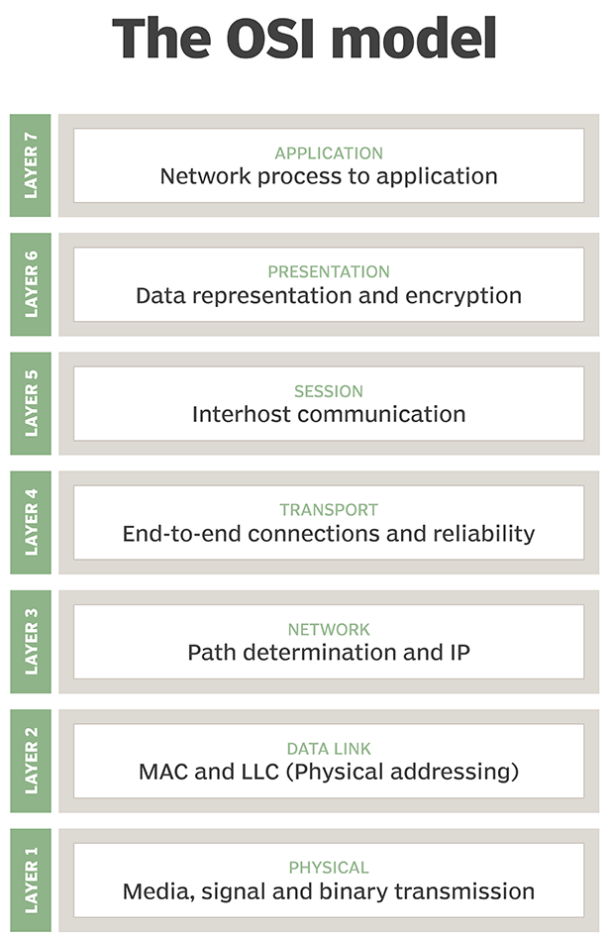
Figure 5 (Kara Gattine, 2021)

7. Application layer
The application layer is the highest level of the OSI model responsible for user interaction with network applications. It defines protocols that enable software to communicate and present data to users. Examples of application layer protocols include HTTP for web browsing, SMTP for email, and FTP for file transfer.

6. Presentation layer
The presentation layer acts as a translator, converting data formats between applications for network compatibility. This layer also handles data encryption and decryption to protect sensitive information during transmission. To enhance efficiency, it compresses data before sending it to reduce data size.

5. Session layer
The session layer is responsible for establishing, managing, and terminating communication sessions between applications on different computers. It ensures a stable connection for efficient data transfer and avoids unnecessary resource consumption. To maintain smooth data flow, especially when dealing with large amounts of data, the session layer introduces checkpoints, allowing data to be divided into smaller segments and recovered from the last checkpoint in case of interruptions.

4. Transport layer
The transport layer is responsible for end-to-end data delivery between applications. It breaks down data into smaller segments, ensures their correct assembly at the destination, and manages data flow to prevent congestion.

Key functions include flow control to regulate data transmission rates and error control to detect and correct data errors. Common transport layer protocols are TCP (Transmission Control Protocol) for reliable, ordered delivery and UDP (User Datagram Protocol) for faster but less reliable delivery.

3. Network layer
The network layer is responsible for inter-network communication. It divides data segments into smaller units called packets and then reassembles them at the destination.

A crucial function of this layer is routing, which involves determining the best path for data transmission across multiple networks. The Internet Protocol (IP) is the primary protocol used at this layer for addressing and routing packets.

2. Data link layer
The data link layer is responsible for reliable data transfer between directly connected nodes. It receives data packets from the network layer and encapsulates them into frames for transmission over the physical medium.

This layer is divided into two sublayers:
- MAC (Media Access Control): Handles frame formatting and access to the physical medium.
- LLC (Logical Link Control): Manages error control and flow control.

To ensure smooth communication, the data link layer uses protocols like ARP (Address Resolution Protocol) to translate IP addresses into MAC addresses, enabling devices with different addressing schemes to communicate.

1. Physical layer
The physical layer is indeed the foundation of network communication. It's where the abstract data represented as ones and zeros is transformed into physical signals that can travel through a medium like copper wire, optical fiber, or wireless signals.

This layer handles the raw transmission of data, ensuring that bits are accurately sent and received. Without the physical layer to bridge the gap between the digital world and the physical world, network communication would be impossible. (Kanade, 2022)

Advantages | Disadvantages
It's considered a standard model in computer networking. | It doesn't define any particular protocol.
The model supports connectionless, as well as connection-oriented, services | Some services are duplicated at various layers, such as the transport and data-link layers.
It has the flexibility to adapt to many protocols. | Layers can't work in parallel; each layer must wait to receive data from the previous layer.
Table 6:advantages and disadvantages of OSI model (Kara Gattine, 2021)

1.2.3. TCP/IP model
TCP/IP is a foundational suite of protocols enabling communication across networks. It outlines how data is divided into packets, addressed, routed, and reassembled at the destination.

While often referred to as TCP/IP, it encompasses a broader set of protocols beyond just TCP and IP. These protocols work together to ensure reliable and efficient data transfer. (Kinza Yasar, 2024)

The TCP/IP splits into 4 layers:
1. Application layer.
2. Transport layer.
3. Internet layer.
4. Network link layer.

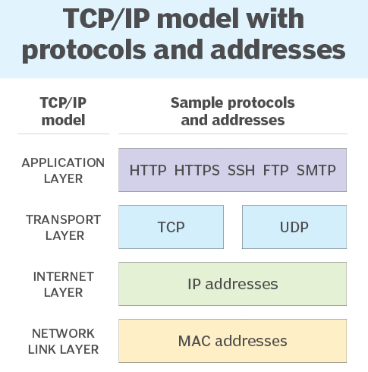
Figure 6 (Kinza Yasar, 2024)

1. Application layer
The top layer of a network is the application layer. It enables different programs to share data using agreed-upon rules. These rules are called protocols, and examples include HTTP, FTP, POP3, SMTP, DNS, DHCP, and SNMP. The actual data sent between programs is referred to as the payload.

2. Transport layer
The transport layer ensures smooth communication between devices on a network. TCP is primarily used for this, guaranteeing reliable data delivery by managing data flow and retransmitting lost data. However, UDP is another option for faster but less reliable data transfer.

3. Internet layer
The network layer, responsible for moving data between different networks, works with data packets. It uses protocols like IP to route these packets and ICMP to handle error messages.

4. Network link layer
The lowest layer of networking, often called the network link or data link layer, handles communication between directly connected devices. It includes protocols like Ethernet for local networks and ARP for finding device addresses. (Kinza Yasar, 2024)

Advantages | Disadvantages
It works independently of the OS. | The transport layer doesn't guarantee the delivery of packets.
TCP/IP supports many routing protocols. | It isn't easy to replace protocols in TCP/IP.
It's lightweight and doesn't place unnecessary strain on a network or computer. | It doesn't clearly separate the concepts of services, interfaces and protocols, so it isn't suitable for describing new technologies in new networks.
It uses a client-server architecture that's highly scalable. | It's especially vulnerable to synchronization attacks, which are a type of denial-of-service attack in which a bad actor uses TCP/IP.
Table 7:advantages and disadvantages of TCP/IP (Kinza Yasar, 2024)

OSI vs TCP/IP
The TCP/IP and OSI models have similarities and differences. The main similarity is in the way they're constructed to both use layers, although TCP/IP consists of just four layers, while the OSI model consists seven layers.

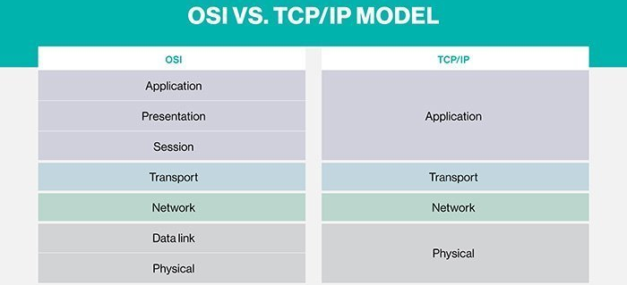
Figure 7 (Kinza Yasar, 2024)

Similarities | Differences
They're both logical models | TCP/IP uses just one layer - the application layer to define the functionalities of the upper layers, while OSI uses three layers - application, presentation and session.
They define networking standards. | TCP/IP uses one layer - the physical layer to define the functionalities of the bottom layers, while OSI uses two layers - physical and data link.
They divide the network communication process into layers. | The TCP/IP header size is 20 bytes, while the OSI header is 5 bytes.
They provide frameworks for creating and executing networking standards and devices | TCP/IP is a protocol-oriented standard, whereas OSI is a generic model based on the functionalities of each layer.
They enable one manufacturer to make devices and network components that can coexist and work with the devices and components made by other manufacturers. | TCP/IP helps establish a connection between different types of computers, whereas OSI helps standardize routers, switches, motherboards and other hardware.
 | TCP/IP follows a horizontal approach, while OSI follows a vertical approach.
Table 8:similarities and differences between OSI and TCP/IP (Kinza Yasar, 2024)

1.3. Network topology
The geometric way of how computers are connected to each other is referred to as Network Topology.

Examples for physical topology:
- Bus topology
- Ring topology
- Star topology
- Mesh topology
- Tree topology

1.3.1. Bus topology
In a bus topology, all devices are connected to a single, shared cable. Data travels along this cable in one direction only. This type of network is simple and straightforward, especially for small setups with two endpoints, often referred to as a linear bus topology. (Pedamkar, 2023)
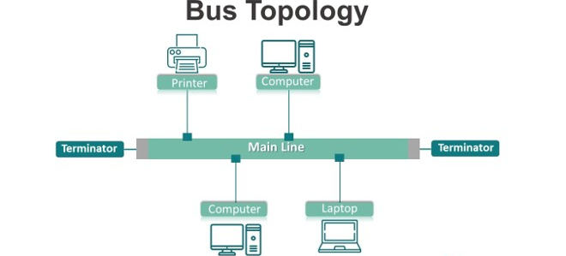
Figure 8 (Pedamkar, 2023)
Advantages | Disadvantages
easy to set up and does not require a lot of cables. | A cable break in the backbone cable can cause the entire network to fail.
It is cost-effective as it requires less cabling and hardware. | As the number of devices increases, the network performance can slow down.
Failure of a single device does not affect the rest of the network | It is challenging to identify and troubleshoot problems in the network.
 | It has limited scalability, as adding new devices to the network is challenging.
Table 9: Advantages and disadvantages of bus topology (Pedamkar, 2023)

1.3.2. Ring topology
In a ring topology, devices like computers, printers, or servers are arranged in a circular configuration, creating a closed loop. Each device is connected to two others, one on each side, and the final device links back to the first, thereby completing the circuit. This arrangement means that every device is connected to two neighboring devices, forming an unbroken ring. Data flows in a single direction around this loop, with each device reading and forwarding the data until it arrives at its intended destination. (Pedamkar, 2023)
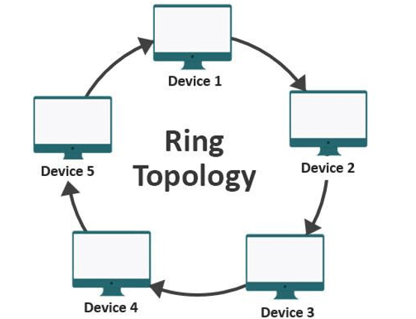
Figure 9 (Pedamkar, 2023)
Advantages | Disadvantages
transmitting data through the other devices in the loop is possible if one device fails | failure of a single device can disrupt the entire network.
each device has an equal opportunity to transmit data, which helps to balance network traffic. | When a failure occurs in a ring topology, it can be challenging to locate the source of the problem
can easily scale up or down by removing or adding devices from the loop. | connecting many devices to the loop can also result in slow performance
there is no need for collision detection or retransmission of data. | Implementing a ring topology can be higher than other topologies, especially if the network needs to cover a large area.
Table 10:advantages and disadvantages of ring topology (Pedamkar, 2023)

1.3.3. Star topology
In a star topology network, every device is directly connected to a central switch or hub, which acts as the main connection point. In this configuration, devices send data through the central hub, which then relays the information to all connected devices. Hubs can be categorized as either active or passive, with active hubs featuring repeaters and passive hubs functioning as non-intelligent nodes. Each node connects directly to the central hub, which operates as a repeater during the transmission of data. (Pedamkar, 2023)
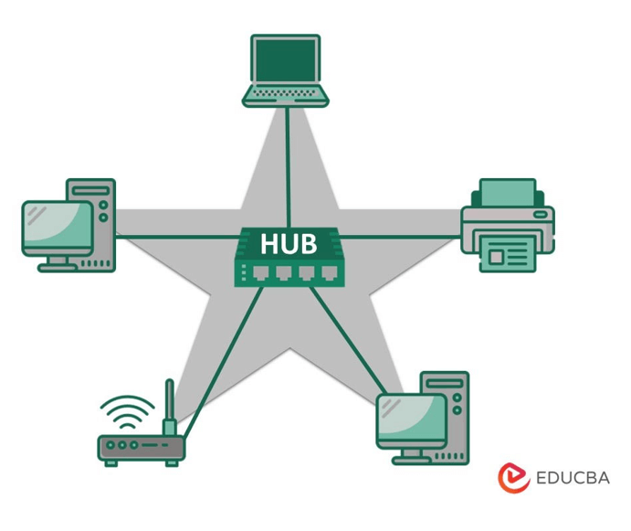
Figure 10 (Pedamkar, 2023)
Advantages | Disadvantages
easy to add or remove devices without disrupting the network and quickly identifying and isolating network problems. | If the hub or switch fails, the entire network can be affected.
if one cable or device fails, it will not impact the rest of the network. | As the number of devices in the network grows, the number of cables required to connect all devices to the hub or switch can become unwieldy
data flow is centralized through the hub, reducing collisions and congestion on the network. | A star topology relies heavily on the hub or switch. The entire network can be affected if the hub or switch is not functioning correctly.
Adding new devices to the network can quickly expand a star topology | While a star topology is easy to manage, setting up and configuring the cabling for an extensive network can be problematic
Table 11: advantages and disadvantages of star topology (Pedamkar, 2023)

1.3.4. Mesh topology
In a mesh network topology, every node is directly linked to all the other nodes through point-to-point connections. This configuration offers multiple possible routes for data transmission between any two devices, ensuring redundancy and resilience in the event of a network disruption or component failure. (Pedamkar, 2023)
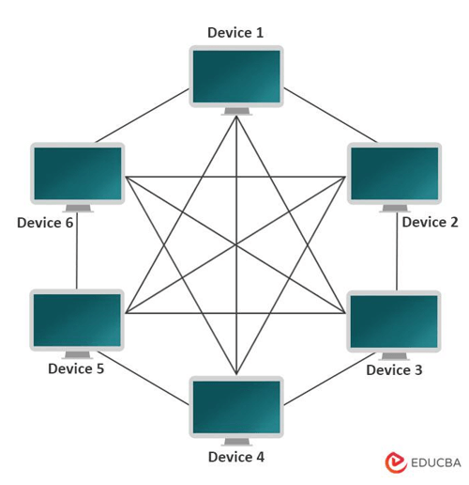
Figure 11 (Pedamkar, 2023)
Advantages | Disadvantages
if one link fails, data can be rerouted through another, ensuring that the network remains operational even in a network failure. | Implementing a mesh topology, especially in large networks, can be expensive
can easily accommodate new devices without disrupting the existing network | Mesh topology can be complex to implement and manage, especially in more extensive networks.
as data can be transmitted over multiple paths between devices, making it difficult for attackers to intercept or disrupt the network. | In a mesh topology, data may need to travel through multiple nodes to reach its destination, increasing latency and affecting network performance
 | The routing protocols used in mesh topology can generate significant network overhead
Table 12:advantages and disadvantages of mesh topology (Pedamkar, 2023)

1.3.5. Tree topology
A tree topology is organized in a hierarchical manner, similar to the structure of a tree. This network configuration features a central node, referred to as the root node, which is connected to one or more child nodes. These child nodes can then connect to additional nodes, forming a branching structure that resembles the branches of a tree. (Pedamkar, 2023)
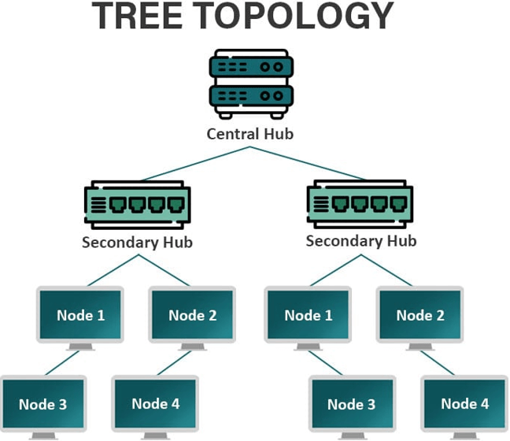
Figure 12 (Pedamkar, 2023)
Advantages | Disadvantages
It is easy to include additional nodes and branches as the network grows without affecting the network’s performance. | The root node in a tree topology represents a single point of failure. The entire network can become unavailable if the root node fails or is disconnected.
The hierarchical structure of a tree topology makes it easier to manage and organize large networks | As the network grows, the complexity of the tree topology can increase, making it more challenging to manage and troubleshoot.
data only needs to travel up or down the hierarchy to reach its destination, making data transmission more efficient and faster. | Maintaining and troubleshooting a tree topology can be more challenging than other topologies, especially if there are issues with the root node or the network branches.
require less cabling and hardware than other topologies, such as mesh or star topologies. | The number of branches created limits the number of nodes in a tree topology. In return, this can restrict the network’s scalability.
Table 13: advantages and disadvantages of tree topology (Pedamkar, 2023)

Topologies and their applications
Topology | Application
bus topology | LANs (Local Area Networks)  Industrial Control Systems  CCTV (Closed Circuit Television) Systems  Educational Networks  Home Networks
ring topology | Local Area Networks (LANs)  Telecommunication Networks  Industrial Control Systems  Fiber Optic Networks
star topology | Local Area Networks (LANs)  Wide Area Networks (WANs)  Telephone Networks  Video Conferencing Systems  Wireless Networks
mesh topology | Wireless Mesh Networks  Industrial Control Systems  Military and Defence Networks  Smart Grids  Peer-to-Peer Networks
tree topology | Telecommunications networks  Computer networks  Data centers  Industrial control systems  Home networks
Table 14: topologies and their applications (Pedamkar, 2023)

- Suitable topology for NetWiz Solutions is star topology. Because, we are going to divide the network for 3 main departments. For these configurations star topology is more suitable that other topologies.

1.4. bandwidth
Network bandwidth refers to the maximum capacity of a wired or wireless communication link to transfer data over a network connection within a specific timeframe. It is usually expressed in bits, kilobits, megabits, or gigabits transmitted per second. Often used interchangeably with capacity, bandwidth indicates the data transfer rate. However, it is important to note that bandwidth does not measure the speed of the network. (Andrew Froehlich, 2021)

Important of bandwidth
Bandwidth is not an infinite resource. In any specific location, whether it be a home or a business, there is a limited amount of capacity available. This limitation can arise from the physical constraints of network devices, such as routers or modems, as well as the cabling or wireless frequencies in use. Additionally, network administrators or internet and wide area network (WAN) providers may intentionally impose bandwidth limits.

When multiple devices share the same connection, they must divide the available bandwidth. Certain devices, like 4K streaming TVs, tend to consume a significant amount of bandwidth, while others, such as those used for webinars, generally require much less. Although speed and bandwidth are distinct concepts, having greater bandwidth is crucial for ensuring acceptable speeds when multiple devices are in use. To clarify this further, here is an overview of the average bandwidth consumption for various services. (Andrew Froehlich, 2021)

Considerations for calculating required bandwidth
To understand how much bandwidth a network uplink or internet broadband requires, follow these four steps:

- Determine which applications will be in use.
- Determine the bandwidth requirements of each application.
- Multiply the application requirements of each application by the number of expected simultaneous users.
- Add all application bandwidth numbers together. (Andrew Froehlich, 2021)
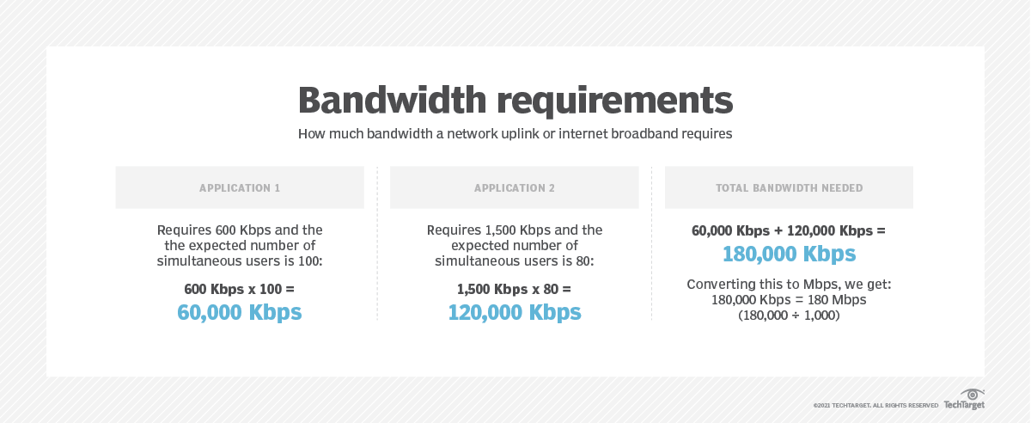
Figure 13 (Andrew Froehlich, 2021)

To assess bandwidth requirements for public or private clouds over internet or WAN connections, the same calculation methods are applicable. However, it is important to note that the available bandwidth on a local area network (LAN) or wireless LAN is generally much higher than that of WAN or dedicated internet access (DIA) connections. Therefore, it is essential to accurately evaluate bandwidth needs and continuously monitor link utilization over time. By tracking bandwidth usage throughout various periods (daily, weekly, monthly or yearly) network engineers can determine if a WAN/DIA link has adequate bandwidth or if an upgrade is necessary.

Insufficient bandwidth can lead to poor performance of applications and services on the network. (Andrew Froehlich, 2021)

1.5. Network devices
Network devices, also known as network hardware, are physical components that enable communication and interaction between various segments of a network. Common examples of these devices include routers, switches, hubs, modems, firewalls, and access points. They play a crucial role in managing traffic flow, directing data packets, ensuring security, and facilitating connectivity between different network segments or the Internet. Each device is designed for a specific function, contributing to a smooth flow of information and connectivity within an organization’s IT infrastructure. (Schrader, 2024)

1.5.1. Repeater
Digital signals transmitted through cables are subject to attenuation, which is the gradual weakening of the signal over distance. The rate at which this weakening occurs is known as the attenuation rate. To counteract this effect, a repeater operating at the physical layer (Layer 1) of the OSI model is employed. A repeater is a powered device that reenergizes the signal, allowing it to continue traveling further without degradation. While dedicated repeaters were commonly used in the past, they have largely been replaced by powered hubs, switches, and routers, which inherently perform the function of a repeater. However, repeaters may still be utilized in specific scenarios, such as extending the range of remote wireless access points. (Schrader, 2024)

1.5.2. Hub
A network hub is a fundamental multiport device used to connect multiple Ethernet devices into a single broadcast network segment. However, this configuration makes hubs susceptible to traffic congestion. There are three main types of hubs:

- Passive hub: This type of hub does not require a power source to connect devices, but it does not provide any signal amplification.
- Active hub: An active hub amplifies incoming signals before broadcasting them and requires an external power source. In this sense, an active hub functions as a repeater.
- Intelligent hub: Intelligent hubs include network management, monitoring, and diagnostic features.

Although hubs were once widely used, they have largely been replaced by switches, which offer improved performance and efficiency. Similar to repeaters, hubs operate at the physical layer (Layer 1) of the OSI model. (Schrader, 2024)

1.5.3. Bridge
While a hub connects multiple devices within a single network, a network bridge serves to connect two or more network segments and filters the traffic between them. Bridges help isolate local segment traffic, thereby reducing congestion and enhancing overall network performance.

A local bridge connects network segments within the same physical location or local area network (LAN), whereas a remote bridge links segments that are geographically separated, often over a wide area network (WAN) connection. There are also two specific types of bridges: transparent bridges and source bridges.

Transparent bridges maintain a MAC address table by analyzing the source addresses of incoming frames and making forwarding decisions based on the destination MAC address found in this table. In contrast, source bridges used a different method and were primarily associated with token ring networks, which are now largely outdated. Both types of bridges operate at the data link layer (Layer 2) of the OSI model. However, it is unlikely that you will encounter either type of bridge in modern networking environments. (Schrader, 2024)

1.5.4. Switch
Network switches are multi-port devices that connect multiple devices within a local area network (LAN). Unlike hubs, switches are equipped with an operating system and possess the intelligence to manage data traffic among connected devices. They utilize MAC addresses to forward data packets directly to their intended destinations. While hubs broadcast data to all connected devices, switches create separate collision domains for each port, enabling one device to communicate exclusively with another. This design allows multiple devices to communicate simultaneously without interference. There are various types of switches available today

Types of Switches
- Unmanaged Switches: These are plug-and-play devices with a fixed configuration that cannot be modified or optimized. They offer limited functionality and lack remote access or monitoring capabilities, making them suitable for small networks or home use.
- Managed Switches: These switches are fully configurable and can be managed or monitored through a web interface, command-line interface, or SNMP session, providing greater control over network traffic.
- Smart Switches: This type of switch offers a middle ground between unmanaged and fully managed switches, providing basic management features accessible through a web interface.
- Layer 2 Switches: Operating at the OSI model’s data link layer (Layer 2), these switches use MAC addresses to forward data within a LAN. They connect local devices within the same network segment, improving network efficiency by reducing collisions and segmenting traffic into separate collision domains.
- Layer 3 Switches: Combining the functionality of a Layer 2 switch and a router, Layer 3 switches are often used in environments with multiple virtual LANs (VLANs). They perform packet switching based on MAC addresses while also incorporating routing capabilities using IP addresses, allowing them to route traffic between different VLANs and subnets.
- PoE Switches: Power over Ethernet (PoE) switches deliver both data and electrical power to network devices through a single Ethernet cable, eliminating the need for separate power supplies. This simplifies installation and reduces cabling, making them ideal for devices like cameras, VoIP phones, and wireless access points.
- Gigabit Switches: These high-speed switches support data transfer rates of 1 gigabit per second (Gbps) or more, facilitating faster network communication.
- Rack-Mounted Switches: Designed to fit into standard 19-inch server racks, these switches are commonly used in data centers and enterprise environments.
- Desktop Switches: Typically used in small or home office settings, desktop switches are compact and can be placed on a desk or tabletop.
- Modular Switches: These flexible switches allow for the addition of various modules or expansion cards, enabling future customization and scalability to meet changing network needs. (Schrader, 2024)

1.5.5. Routers
The primary function of a router is to guide network traffic. These devices direct data packets to their intended destinations by mapping out efficient paths through interconnected network components, utilizing various network topologies. Routers are intelligent systems that maintain comprehensive information about their connected networks. Many routers employ access control lists (ACLs) to regulate traffic flow, and some even serve as packet-filtering firewalls.
Furthermore, routers have the capability to divide internal networks into multiple subnetworks and can be interconnected with other routers, creating autonomous zones. These devices establish communication by continuously updating routing tables with information about destinations and local connections. When a router encounters a destination it doesn't have direct knowledge of, it utilizes the stored information about connected routers to forward the packets accordingly. Routers operate at the network layer (Layer 3) of the OSI model.

- A static router relies on manually set routes to manage network traffic, ensuring that data packets follow consistent, predefined paths without adapting to changes in the network. This type of router is well-suited for smaller networks.

- In contrast, a dynamic router automatically interacts with other dynamic routers to adjust its routing table according to real-time network conditions. It utilizes dynamic routing protocols such as OSPF, RIP, or BGP to share information about network topology and link statuses with other routers. These protocols allow routers to identify the most efficient paths, adapt to network changes, and reroute traffic effectively. Dynamic routers continually refresh their routing tables, enabling automatic failover and load balancing. They can swiftly respond to network failures or congestion by finding alternative routes, making them particularly advantageous for large and complex networks where manual configuration would be cumbersome. (Schrader, 2024)

1.5.6. Gateway
A gateway is a widely used network device that connects different networks and facilitates communication between them. It acts like a translator, converting data from one protocol or format to another, which ensures compatibility across various network environments. Gateways are crucial for communication that needs to cross different network architectures. A common example is a local area network (LAN) connecting to a wide area network (WAN) or the internet. These devices typically operate at the Transport and Session layers (Layers 5 and 6) of the OSI model. Additionally, gateways may include security features such as firewalls and provide functionalities for optimizing network performance. (Schrader, 2024)

1.5.7. Firewall
A firewall is a network security device that creates a barrier between trusted internal networks and untrusted external networks. It connects various areas known as zones, including LAN, WAN, and DMZ. By applying designated security policies, firewalls filter traffic by analyzing the data packets that move between these zones, with the internet being the most untrusted network. Firewalls can also be implemented within the internal network to separate departments that manage sensitive information, such as Human Resources or Finance. They can be hardware-based, software-based, or a combination of both. Firewalls may utilize blocklists (or deny lists) that permit all traffic except for specific types. For tighter security, an allowlist (or allow list) can be used, which blocks all traffic except for what is explicitly permitted. There are several types of firewalls, and the appropriate choice depends on your specific needs. Some of the most common types include:

- Packet Filtering: Functions as a network layer checkpoint, evaluating data packets based on IP address, packet type, port number, or network protocols.
- Stateful Inspection: Examines data at both the network and transport layers, assessing source IP, destination IP, source port, and destination port.
- Next-Generation Firewall (NGFW): This advanced security device surpasses traditional firewall functions and incorporates multiple security features. Examples include deep packet inspection, intrusion prevention systems (IPS), application awareness and control, and advanced threat detection. NGFWs may also leverage AI to address complex threats by analyzing packet contents and identifying applications and potential risks within the traffic. (Schrader, 2024)

1.5.8. Modem
A modem, an abbreviation for modulator-demodulator, is a device that transforms digital data into analog signals with different frequencies for transmission across various communication channels such as telephone lines or cable systems. It also performs the reverse process, converting incoming analog signals back to digital format. This capability is crucial for facilitating internet access offered by Internet Service Providers (ISPs). Modems come in four main varieties:
- DSL Modem: Employs telephone lines and is typically regarded as the slowest connection option.
- Cable Modem: Uses TV cable infrastructure to transmit data, providing faster speeds compared to DSL.
- Wireless Modem: Enables device connectivity through Wi-Fi networks, depending on available Wi-Fi signals in the vicinity.
- Cellular Modem: Provides internet connectivity via cellular networks, eliminating the need for Wi-Fi or wired connections. (Schrader, 2024)

1.5.9. WAP (Wireless Access Point)
A wireless access point (WAP) is a networking device equipped with an antenna, transmitter, and adapter. It serves as a connection point between wireless local area networks (WLANs) and wired Ethernet LANs, using the wireless infrastructure network mode. To connect to a wireless network, a service set identifier (SSID) name is required. This SSID identifies all systems within the same network, and client stations must be configured with it for authentication. WAPs can broadcast the SSID or, for security reasons, be configured not to do so, requiring manual SSID input by an administrator. Network size determines the number of WAPs needed for full coverage. Each WAP has a limited transmission range, influenced by factors such as wireless standard, obstructions, and environmental conditions. High-end WAPs with powerful antennas can extend wireless signal range. Various types of WAPs exist:
- Standalone Access Points: Independent devices suitable for small networks.
- Controller-Based Access Points: Managed by a central controller, ideal for larger networks requiring centralized administration.
- Cloud-Managed Access Points: Offer remote management via cloud platforms, suitable for distributed networks and multi-site businesses.
- USB Access Points: Portable devices creating wireless hotspots, useful for temporary setups or travel. (Schrader, 2024)

1.6. Server types
A server is a robust device specifically built to process, store, and oversee data, devices, and systems within a network. This advanced computing system offers resources to networking components to deliver specialized services, including displaying web pages and facilitating email communication, among other functions.

Today, there are various types of servers available. Many servers can handle multiple tasks, including hosting websites, managing email communications, and protecting internal networks. In contrast, dedicated servers, like database servers or print servers, are designed to focus on a specific function. (Kanade, 2023)

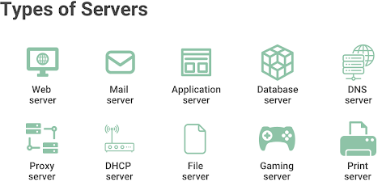
Figure 14 (Kanade, 2023)

1.6.1. Web server
Web servers are built to operate websites and applications through client programs (web browsers) such as Internet Explorer, Chrome, Firefox, Opera, or Safari. They manage the storage, processing, and delivery of web content to users. These servers support protocols like HTTP, FTP, and SMTP, which are essential for the exchange of information between network devices.

In a network, all machines hosting websites utilize web server software to efficiently manage user access to hosted files. Examples of web servers include Apache HTTP Server, Microsoft Internet Information Services (IIS), and Sun Microsystems’ Sun Java System Web Server. (Kanade, 2023)

1.6.2. Mail server
Mail servers are designed to handle email storage and management for clients. They employ distinct protocols for sending and receiving emails. For instance, the Simple Mail Transfer Protocol (SMTP) is utilized for sending emails, while the Post Office Protocol (POP3) is used for storing and receiving emails.

These servers function similarly to a traditional post office, organizing and storing mail before dispatching it to its intended destination. In essence, when a user sends an email to another computer, the mail server is tasked with delivering it to the specified recipient. Mail servers depend on various software components that enable emails to be sent, received, retrieved, and forwarded. (Kanade, 2023)

1.6.3. Application server
An application server provides a platform for developing, processing, and running web-based applications, regardless of their specific functions. It executes computer programs or scripts necessary for operating PHP, Java, or .Net applications.

These servers share similarities with web servers, as they often use HTTP protocol and respond to client requests. However, application servers primarily focus on generating dynamic websites that utilize features like object pooling and messaging services, such as e-commerce sites and blogs. In contrast, web servers are more oriented towards creating static websites where content remains unchanged, like technical documentation sites, corporate portfolios, read-only websites, and landing pages. (Kanade, 2023)

1.6.4. Database server
Database servers provide database services to client machines, allowing users to access, modify, store, and retrieve data by running queries, such as SQL queries. These servers manage the security and recovery aspects of database management systems (DBMS). They also store digital files, application files, and non-database files. Large organizations rely on these servers to protect their sensitive and valuable corporate data. Examples of database servers include Microsoft SQL, MySQL, MongoDB, and SQLite. (Kanade, 2023)

1.6.5. DNS server
DNS servers, or domain name servers, are computers that resolve server names within a network. They play a crucial role in the internet by converting user-friendly URLs into their associated IP addresses. (Kanade, 2023)

1.6.6. Proxy server
Proxy servers function as intermediaries between local and global networks, facilitating communication by accepting requests from one network and forwarding them using their own IP address. They improve efficiency by caching frequently visited web pages, enabling faster loading times and reducing network bandwidth usage.

Additionally, proxy servers filter network traffic and maintain constant availability, which is essential for balancing network loads. They also provide anonymity for clients by substituting their original IP addresses with proxy addresses. (Kanade, 2023)

1.6.7. DHCP server
Dynamic Host Configuration Protocol (DHCP) servers are computer systems that automatically assign IP addresses to clients. This automated process reduces errors that can occur with manual assignment, such as typos or IP address conflicts.

These servers manage network device configurations, including updating expired IP addresses and handling IP addresses for devices that change locations. DHCP servers are crucial for network administration, as they can efficiently handle multiple client requests simultaneously. (Kanade, 2023)

1.6.8. File server
A file server is a machine that offers shareable disks accessible to workstations on a network. These disks store various types of computer files, including text, images, graphics, audio, and video files. Primarily used for storage, file servers do not run computer programs or perform computational tasks. (Kanade, 2023)

Depending on the computing environment, file servers use different protocols to access files. For instance, internet file servers are accessed via FTP and HTTP protocols, while file servers on local area networks (LAN), such as those in offices and schools, use SMB or NFS protocols. (Kanade, 2023)

1.6.9. Gaming server
Gaming servers connect the worldwide online gaming community, facilitating multiplayer games like Counter-Strike and Minecraft. These servers handle player and game data while synchronizing player activities within the virtual environment. Popular game server hosting solutions, such as ScalaCube, HostHavoc, and Cloudzy, offer rental services for game servers used in titles like ARK, Rust, and more. (Kanade, 2023)

1.6.10. Print server
Print servers act as intermediaries, linking printing devices to clients on a network. They receive print jobs from users and organize them into queues, anticipating potential printer overload during peak times. These servers employ various protocols to manage print jobs, including Internet Printing Protocol, Line Printer Daemon protocol, and JetDirect. In the print server market, well-known brands include IOGEAR and HP. (Kanade, 2023)

- In our NetWiz Solutions scenario we only have 3 main departments. For this scenario we are only going to install File server for each 3 departments. Its enough for our company to store files and use this as a storage.

1.7. Interdependence between workstation hardware and networking software
In any computer network, workstation hardware and networking software are mutually dependent elements. The physical resources needed for software operation are supplied by the hardware, while the software facilitates communication between the hardware and other network devices.

Let's explore their interdependence:
- NICs and Their Drivers: Workstations need NICs for network connectivity. These cards rely on software drivers to interact with the operating system and networking protocols. The NIC cannot operate properly without the correct driver software.

- OS Impact: The workstation's operating system choice significantly affects network functionality. Network support varies across different operating systems. The OS incorporates essential networking software, like the TCP/IP stack, to ensure proper communication with other network devices.

- Security Software: Workstations require security applications such as firewalls and antivirus programs to guard against network threats. These software tools collaborate with the hardware to oversee network traffic and implement security measures. The hardware's capabilities can influence these security tools' effectiveness.

- Network Communication Protocols: Software protocols like TCP/IP, UDP, HTTP, and DNS are vital for enabling workstation communication with other network devices. These protocols define data structure, transmission, and reception methods. Network hardware components depend on this software for efficient data routing.

- Virtualization Technology: Modern networking heavily relies on virtualization. This software allows the creation of virtual network components within physical hardware. It enables multiple operating systems and network configurations to run on a single physical machine through virtual machines and containers.

- Network Management Software: Applications for managing and monitoring network performance depend on workstation hardware to provide up-to-date network activity data. The hardware's performance can impact the precision and speed of network monitoring and management processes.

- Remote Access and Collaboration Applications: Software for remote access and teamwork, such as remote desktop and video conferencing tools, is crucial. These applications require workstations with adequate processing power, memory, and network capabilities to ensure a seamless user experience. (Gupta, 2023)

To conclude, workstation hardware and networking software are closely linked. The hardware provides the physical foundation, while networking software enables hardware communication with other network devices and services. The selection of hardware and its compatibility with networking software can significantly influence a workstation's ability to operate effectively in a networked environment.

Activity 2

2.1. Network Design

2.1.1. IP Addressing Scheme:
- Subnet Mask: 255.255.255.224 (/27)
- Total IPs per Subnet: 32 (30 usable IPs)
- Subnets:
  - Marketing: 10.10.1.0/27
  - IT Support: 10.10.1.32/27
  - Administration: 10.10.1.64/27
- Gateway for each subnet:
  - Marketing: 10.10.1.1
  - IT Support: 10.10.1.33
  - Administration: 10.10.1.65

2.1.2. VLAN Configuration:
- VLAN 10 (Marketing): Devices assigned to this VLAN will be on the 10.10.1.0/27 subnet.
- VLAN 20 (IT Support): Devices assigned to this VLAN will be on the 10.10.1.32/27 subnet.
- VLAN 30 (Administration): Devices assigned to this VLAN will be on the 10.10.1.64/27 subnet.

Note: We are going to assign IP addresses for end devices using DHCP method. We will create DHCP pool for each VLAN.

Special Note: Also we can assign static IP addresses for our network printers and file servers.

2.1.3. IP Address Allocation Table
This table clearly shows the IP allocation and VLAN divisions for every device in the network.
Department | VLAN | Total Number of Devices | Network Address | Device Types | Assignable IP Address Range | Default Gateway | Usable IP Range
Marketing | VLAN 10 | 20 | 10.10.1.0 | 18 PCs. | 10.10.1.2-  10.10.1.28 | 10.10.1.1 | 10.10.1.1  - 10.10.1.30
 |  |  |  | 1 Network Printer. | 10.10.1.29 | 10.10.1.1 | 10.10.1.1  - 10.10.1.30
 |  |  |  | 1 File Server. | 10.10.1.30 | 10.10.1.1 | 10.10.1.1  - 10.10.1.30
IT Support | VLAN 20 | 12 | 10.10.1.32 | 10 PCs. | 10.10.1.34-  10.10.1.60 | 10.10.1.33 | 10.10.1.33 - 10.10.1.62
 |  |  |  | 1 Network Printer. | 10.10.1.61 | 10.10.1.33 | 10.10.1.33 - 10.10.1.62
 |  |  |  | 1 File Server. | 10.10.1.62 | 10.10.1.33 | 10.10.1.33 - 10.10.1.62
Administration | VLAN 30 | 26 | 10.10.1.64 | 24 PCs. | 10.10.1.66-  10.10.1.92 | 10.10.1.65 | 10.10.1.65 - 10.10.1.94
 |  |  |  | 1 Network Printer. | 10.10.1.93 | 10.10.1.65 | 10.10.1.65 - 10.10.1.94
 |  |  |  | 1 File Server. | 10.10.1.94 | 10.10.1.65 | 10.10.1.65 - 10.10.1.94
Table 15:IP and VLAN allocation
Note:
- Subnet mask for this network is 255.255.255.224
- We allocated two static IP addresses for printer and server in each department.
- For all the PCs in the network, we created DHCP pool for their respective VLANs.

2.1.4. Visual design for the network
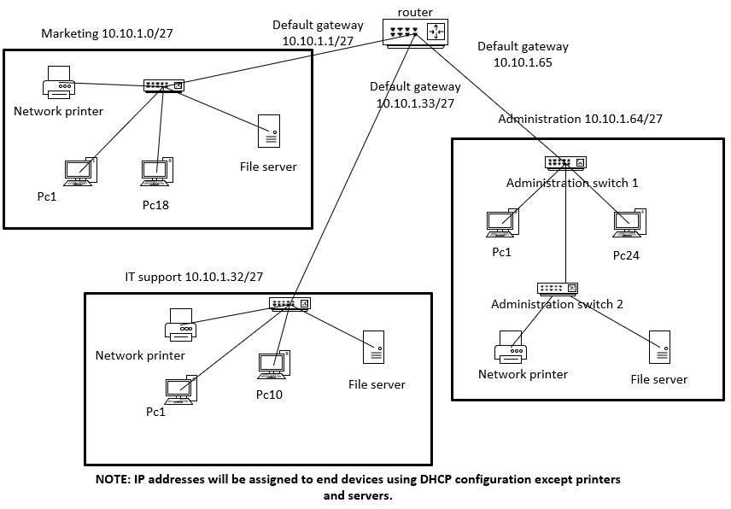
Figure 15:Visual design of the network
This image clearly shows the model drawing of our network. We can deeply discuss the details about the network in the implementation phase.

2.2. Networking Hardware
- 4 Switches (2960):
  - Switch 1: 24-port managed switch for Marketing.
  - Switch 2: 16-port managed switch for IT Support.
  - Switch 3: 24-port managed switch for Administration.
  - Switch 4: Additional switch for Administration to extend the number of available ports.
- 1 Router (2911):
  - A router with VLAN support to manage inter-VLAN routing.
- Network Cables:
  - Cat6 Ethernet cables for all connections.

2.3. VLAN Setup
- Configure VLANs on Each Switch:
  - Switch 1 (Marketing):
    - Assign all ports to VLAN 10.
  - Switch 2 (IT Support):
    - Assign all ports to VLAN 20.
  - Switch 3 & Switch 4 (Administration):
    - Assign all ports to VLAN 30.
- Connect Switches:
  - Switch 1 to Router: Connect the Marketing switch to the router.
  - Switch 2 to Router: Connect the IT Support switch to the router.
  - Switch 3 and Switch 4:
    - Stack or Cascade Switch 3 and Switch 4:
      - Use a cross-over cable or trunk port to link Switch 3 and Switch 4, effectively combining their ports into a single logical switch for the Administration department.
    - Connect one of these switches (preferably Switch 3) to the router.
- Router Configuration:
  - Configure the router to handle inter-VLAN routing so devices in different VLANs can communicate if needed.

2.4. Network Address and Device Connections
Devices Allocation:
- Marketing (VLAN 10):
  - PCs, Network Printer, File Server: 10.10.1.2 - 10.10.1.30
- IT Support (VLAN 20):
- PCs, Network Printer, File Server: 10.10.1.34 - 10.10.1.62
- Administration (VLAN 30):
- PCs, Network Printer, File Server: 10.10.1.66 - 10.10.1.94

2.5. Physical location within the organization
All router, switches and devices are place in the same building in separate rooms.

Room 1
  - Switch 1 (Marketing): Connect all Marketing PCs, the printer, and the file server to this switch.

Room 2
  - Switch 2 (IT Support): Connect all IT Support PCs, the printer, and the file server to this switch.

Room 3
  - Switch 3 and Switch 4 (Administration):
    - Distribute the 24 PCs between the two switches.
    - Connect the network printer and file server to either Switch 3 or Switch 4.

2.6. Security Consideration
Restricting Inter-Departmental Communication
To enhance security and maintain network segmentation, it is advisable to restrict devices within each department to communicate only within their respective VLANs. This setup limits the ability of devices in one department to directly interact with devices in another, thereby reducing the risk of unauthorized access or lateral movement within the network.

VLAN Configuration:
- Each department operates on a separate VLAN (VLAN 10 for Marketing, VLAN 20 for IT Support, and VLAN 30 for Administration). VLANs inherently segment network traffic, preventing devices in different VLANs from communicating directly without routing.

2.7. Network maintenance schedule
Task | Frequency | Description
Backup Configuration Files | Weekly | Backup all router and switch configuration files to ensure recovery in case of device failure.
Update Firmware/Software | Monthly | Check for and apply firmware/software updates on all network devices to ensure security and performance.
Check for Security Updates | Weekly | Review and apply the latest security patches and updates for all network devices and systems.
Inspect Physical Connections | Quarterly | Verify all cables, ports, and physical connections are secure and free from wear or damage.
Review and Optimize Performance | Monthly | Analyse network performance, check for bottlenecks, and optimize configurations as needed.
Monitor Network Traffic | Continuous | Use monitoring tools to detect unusual traffic patterns and potential security threats.
Test Disaster Recovery Plan | Annually | Simulate a network failure and perform a full recovery to test the effectiveness of the disaster recovery plan.
Update Network Documentation | Quarterly | Ensure that all network diagrams, configurations, and documentation are up-to-date and accurate.
Clean Equipment and Server Rooms | Semi-Annually | Physically clean dust and debris from network equipment and server rooms to maintain optimal operating conditions.
Check and Replace Backup Power Supplies | Annually | Inspect and replace UPS batteries and power supplies to ensure network uptime during power outages.
Table 16: maintenance schedule for the network

Description
- Backup Configuration Files: Regular backups ensure that in case of device failure, the network configuration can be quickly restored without major disruptions. Weekly backups are recommended to capture recent changes.
- Update Firmware/Software: Keeping firmware and software up to date is critical for maintaining network security and performance. Monthly checks ensure devices are running the latest, most secure versions.
- Check for Security Updates: Regularly reviewing security patches protects the network from vulnerabilities. Weekly checks help in promptly applying critical updates.
- Inspect Physical Connections: Quarterly inspections help prevent issues due to loose or damaged cables, which could lead to network downtime or degraded performance.
- Review and Optimize Performance: Monthly performance reviews allow for the identification and resolution of bottlenecks or other issues, ensuring the network operates efficiently.
- Monitor Network Traffic: Continuous monitoring is essential for detecting unusual activities that might indicate security breaches or network issues.
- Test Disaster Recovery Plan: Annual testing of the disaster recovery plan ensures that the network can be quickly restored in the event of a major outage or failure, minimizing downtime.
- Update Network Documentation: Up-to-date documentation is crucial for troubleshooting and maintaining the network. Quarterly reviews keep the information current and accurate.
- Clean Equipment and Server Rooms: Regular cleaning helps maintain optimal operating conditions by preventing dust and debris buildup, which can cause overheating or hardware failures.
- Check and Replace Backup Power Supplies: Annual inspection and replacement of UPS batteries ensure that the network remains operational during power outages, preventing data loss or hardware damage.

This maintenance schedule helps to ensure the reliability, security, and efficiency of the networked system by proactively addressing potential issues before they cause significant disruptions.

2.8. Test plan for the networked system
Test Area | Test Action | Test Data | Expected Results
1. VLAN Configuration | Create and verify VLANs on switches. | Use show vlan brief command. | VLANs 10, 20, and 30 should be created and assigned correctly.
2. Trunking Between Switches | Configure and verify trunk ports between administration Switch 1 and 2. | Use show interfaces trunk command. | Trunk links should allow VLAN traffic to pass between switches.
3. DHCP Configuration | Set up DHCP pools for each VLAN on the router. | Set end devices to DHCP. | Devices should receive correct IPs from their respective DHCP pools.
4. Default Gateway Configuration | Assign the last usable IP of each subnet as the gateway. | Ping the default gateway from each device. | Devices should successfully ping their assigned gateway.
5. Network Security (VLAN Isolation) | Ensure VLANs are isolated (no direct cross-VLAN pings). | Attempt to ping between VLANs directly. | Devices in different VLANs should not ping each other directly.
Table 17: test plan for the networked system
Description of Test Areas
- VLAN Configuration: Verify that VLANs are correctly set up on each switch in Cisco Packet Tracer.
- Trunking Between Switches: Ensure trunk links are properly configured to carry VLAN traffic between Switch 3 and Switch 4.
- DHCP Configuration: Set up DHCP on the router and verify that end devices receive IPs automatically from the correct VLAN pool.
- Default Gateway Configuration: Set the default gateway as the last usable IP address in each VLAN's subnet and test by pinging from devices.
- Network Security (VLAN Isolation): Test that devices in one VLAN cannot directly communicate with devices in another VLAN without routing.
- Printer and File Server Accessibility: Ensure that devices can access printers and file servers within their assigned VLANs.

This plan ensures that all critical aspects of your network configuration are tested within Cisco Packet Tracer, focusing on VLANs, VLAN routing, DHCP, and security.

Activity 3

3.1. Implementation of the optimized design for the network

3.1.1. Network Design and Initial Setup
- Device Selection: Chose a Cisco 2911 router and Cisco 2960 switches for the network.
- Topology Design:
  - Switch 1 (Marketing): Connected to Router interface Gig0/0.
  - Switch 2 (IT Support): Connected to Router interface Gig0/1.
  - Switch 3 (Administration): Connected to Router interface Gig0/2.
  - Switch 4 (Administration): Connected to Switch 3 via a trunk link.
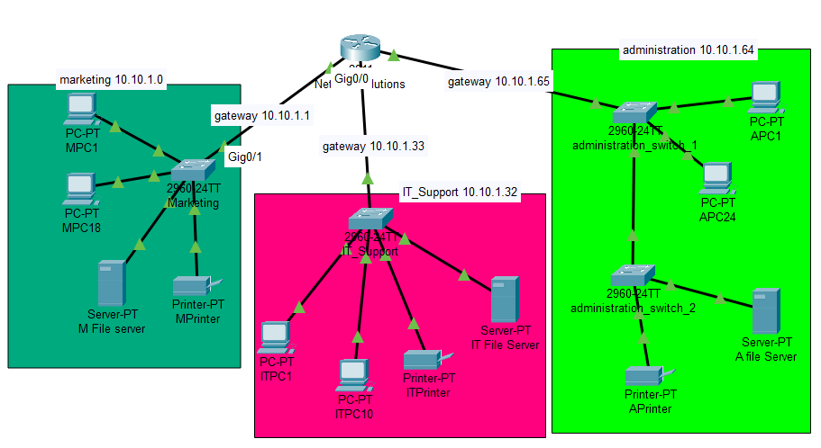
Figure 16: implemented design in cisco packet tracer

Special Note: I also added my implemented plan with all the configurations of CISCO Packet Tracer file within the same folder of this report. Please consider that file for more comprehension.

3.1.2. Router Configuration
- Assign Default gateway IP address for marketing switch in router
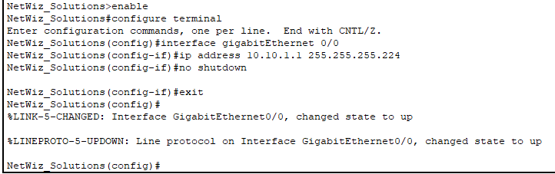
Figure 17:Default gateway IP address for marketing switch

- Assign Default gateway IP address for IT_Support switch in router
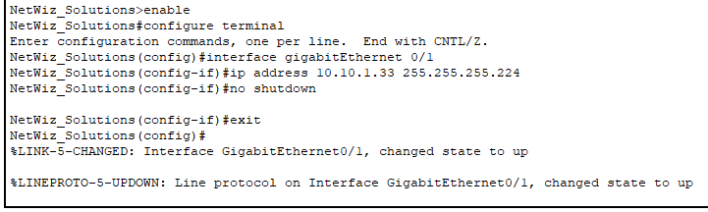
Figure 18:Default gateway IP address for IT_Support

- Assign Default gateway IP address for administration switch 1 in router
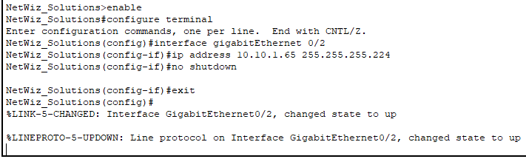
Figure 19:Default gateway IP address for administration
- Excluding default gateway addresses before creating DHCP pools in router
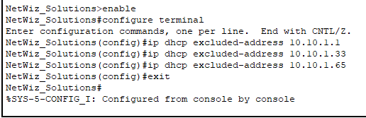
Figure 20:Excluding default gateway addresses before creating DHCP pools
- Excluding printer and server’s addresses before creating DHCP pools in router
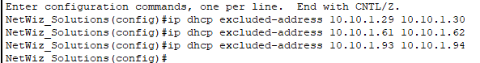
Figure 21:EXcluding IP addresses for printers and servers

3.1.3. VLAN isolation configuration
- Creating ACLs to isolate VLANs
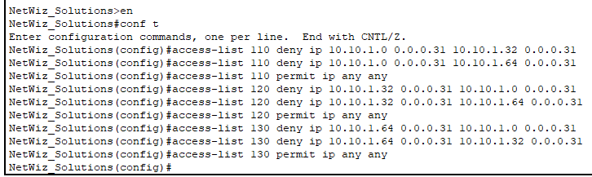
Figure 22:creating ACLs
- Applying ACLs to isolate VLANs
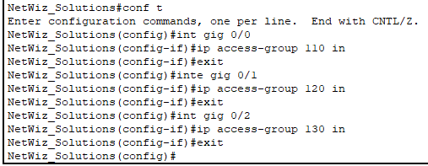
Figure 23:Applying ACLs

3.1.4. DHCP Configurations
- Creating DHCP pool for VLAN 10 in router
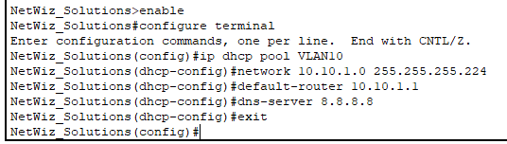
Figure 24:DHCP pool for VLAN 10

- Creating DHCP pool for VLAN 20 in router
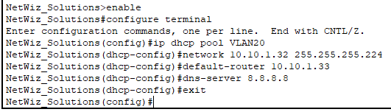
Figure 25:DHCP pool for VLAN 20

- Creating DHCP pool for VLAN 30 in router
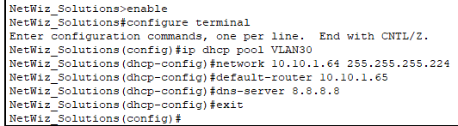
Figure 26:DHCP pool for VLAN 30

3.1.5. VLAN Configuration
- Creating VLAN 10 and giving VLAN 10 access to the gigabitEthernet interface in the marketing switch
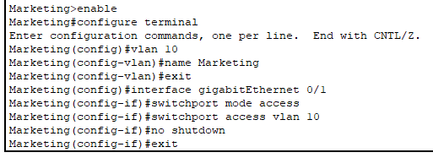
Figure 27:Creating VLAN 10 and giving VLAN 10 access

- Creating VLAN 20 and giving VLAN 20 access to the gigabitEthernet interface in the IT_Support switch
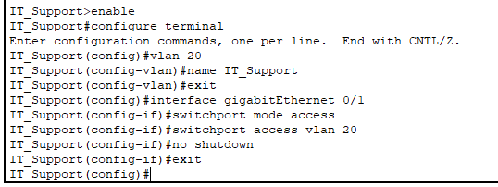
Figure 28:Creating VLAN 20 and giving VLAN 20 access

- Creating VLAN 30 and giving VLAN 30 access to the gigabitEthernet interface in the administration switch 1
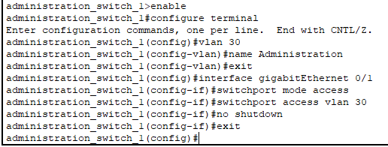
Figure 29:Creating VLAN 30 and giving VLAN 30 access

3.1.6. Trunk configurations
- Configuring trunk in administration switch 1
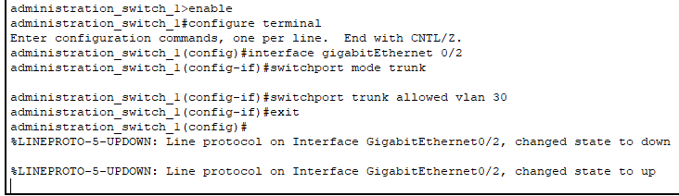
Figure 30:Configuring trunk in administration switch 1

- Configuring trunk in administration switch 2
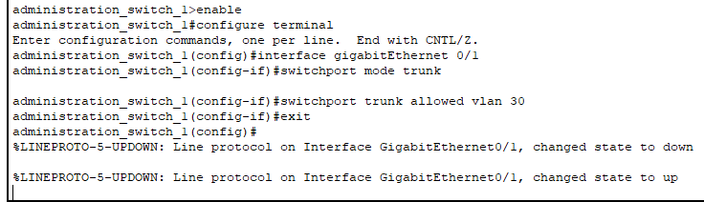
Figure 31:Configuring trunk in administration switch 2

3.1.7. Switchport configurations
- Creating VLAN 10 access to the interfaces in marketing switch
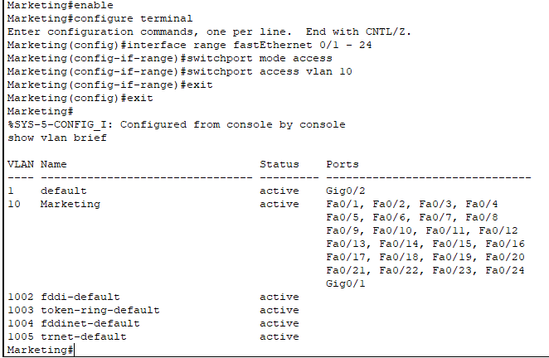
Figure 32:Creating VLAN 10 access to the interfaces in marketing switch

- Creating VLAN 20 access to the interfaces in IT_Support switch
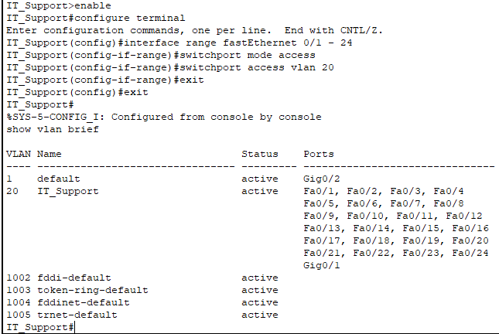
Figure 33:Creating VLAN 20 access to the interfaces in IT_Support switch

Creating VLAN 30 access to the interfaces in administration switch 1
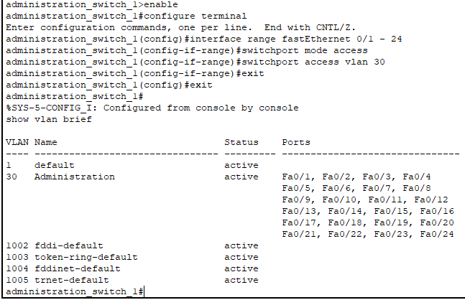
Figure 34:Creating VLAN 30 access to the interfaces in administration switch 1

Creating VLAN 30 access to the interfaces in administration switch 2
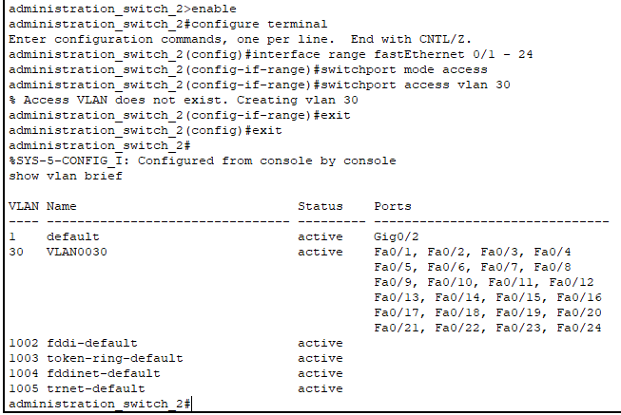
Figure 35:Creating VLAN 30 access to the interfaces in administration switch 2

3.1.8. IP Address Assignment
- Configured all end devices to use DHCP, allowing them to automatically obtain IP addresses from the router.
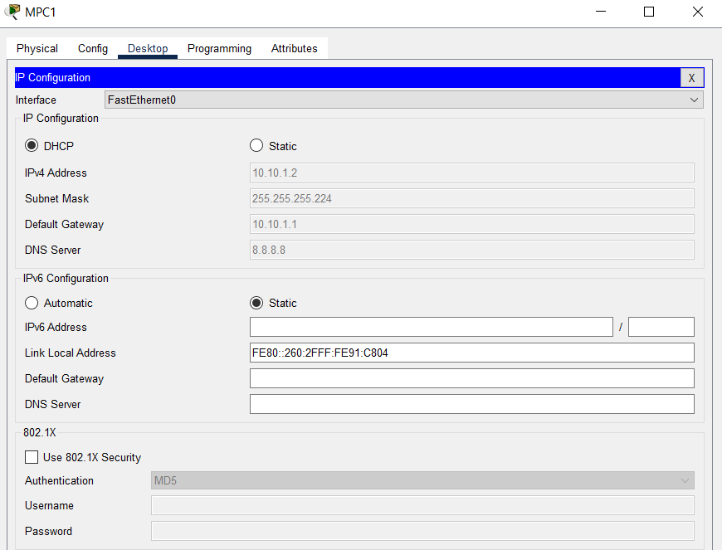
Figure 36:assign DHCP IP to the end devices
- For every server and Printer in every department. we should configure static IP manually like this.
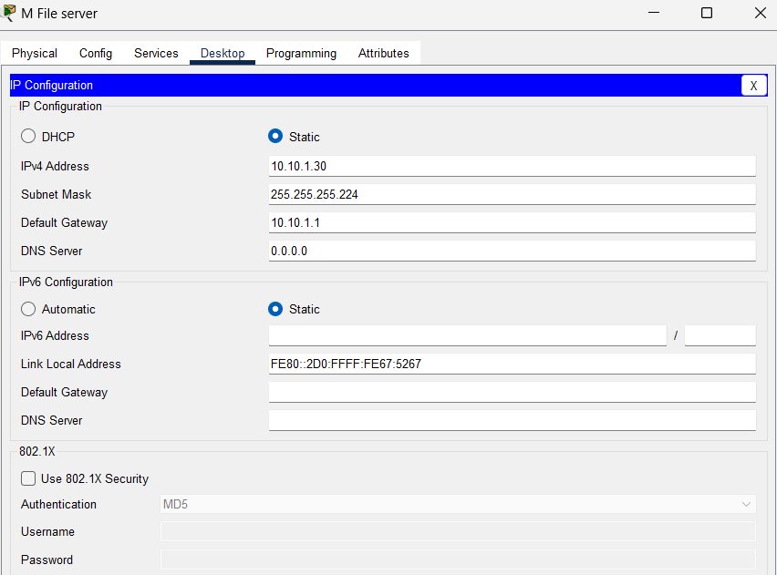
Figure 37:assigning static IP address for the server in VLAN 10

3.1.9. Checking briefs on CLI
- checking IP routing in router
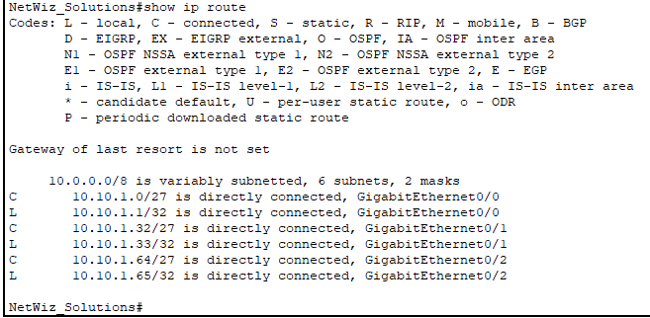
Figure 38:IP routing brief

- Checking DHCP pool brief
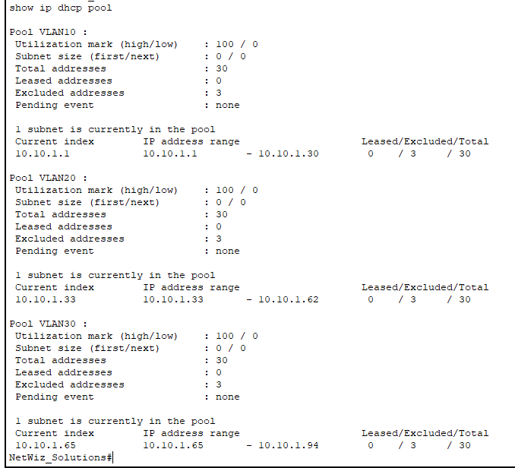
Figure 39:DHCP pool brief
- Checking IP interface brief
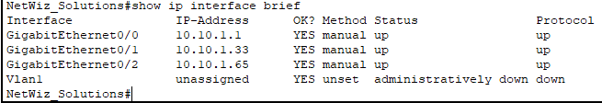
Figure 40:IP interface brief (router)

3.2. test plan implementation and actual results

1. VLAN Configuration
- Test Action: Verify that VLANs 10, 20, and 30 are created on each switch.
- Test Data: Use show vlan brief command.
- Expected Results: VLANs 10, 20, and 30 should be listed, each with the correct status and ports assigned.

Use vlan brief command in marketing switch
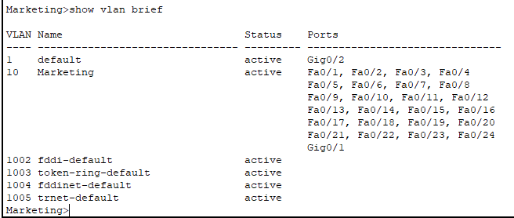
Figure 41:vlan brief of marketing switch

Use vlan brief command in IT_Support switch
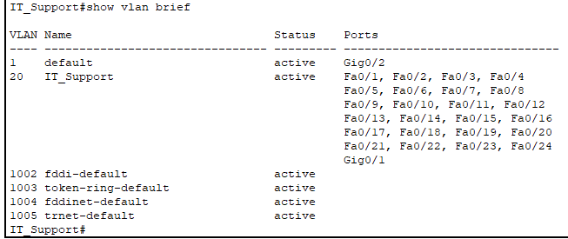
Figure 42:vlan brief of IT_Support switch

Use vlan brief command in administration switch 1
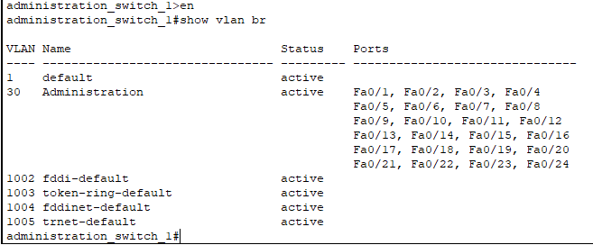
Figure 43:vlan brief of administration switch 1

Use vlan brief command in administration switch 2
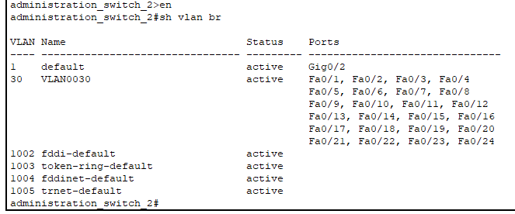
Figure 44:vlan brief of administration switch 2

Actual Results:
VLAN ID | VLAN Name | Status | Ports Assigned
10 | Marketing | Active | Ports on marketing Switch
20 | IT Support | Active | Ports on IT_Support Switch
30 | Administration | Active | Ports on administration Switch 1 and 2
Table 18:actual results of test 1
status: VLANs are correctly configured as per the requirements.

2. Trunking Between Switches
- Test Action: Configure trunk ports between administration Switch 1 and Switch 2, and verify VLANs allowed.
- Test Data: Use show interfaces trunk command.
- Expected Results: VLANs 30 should be allowed on the trunk link.

Use show interfaces trunk command in administration switch 1
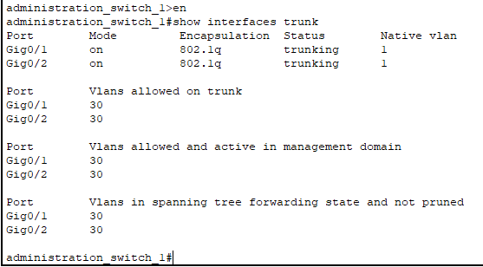
Figure 45: trunk interface brief of administration brief 1

Use show interfaces trunk command in administration switch 2
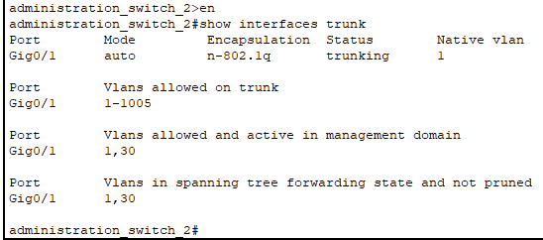
Figure 46:trunk interface brief of administration switch 2

Actual Results:
Switches | Allowed VLANs
Administration Switch 1 to Switch 2 | 30
Table 19:actual results of test 2
Notes: Trunk links correctly allow the required VLANs.

3. DHCP Configuration
- Test Action: Set up DHCP pools and verify IP assignment.
- Test Data: Set end devices to DHCP and check IP configuration.
- Expected Results: Devices should receive IP addresses from their respective VLAN pools.

Setting DHCP to a PC in VLAN 10
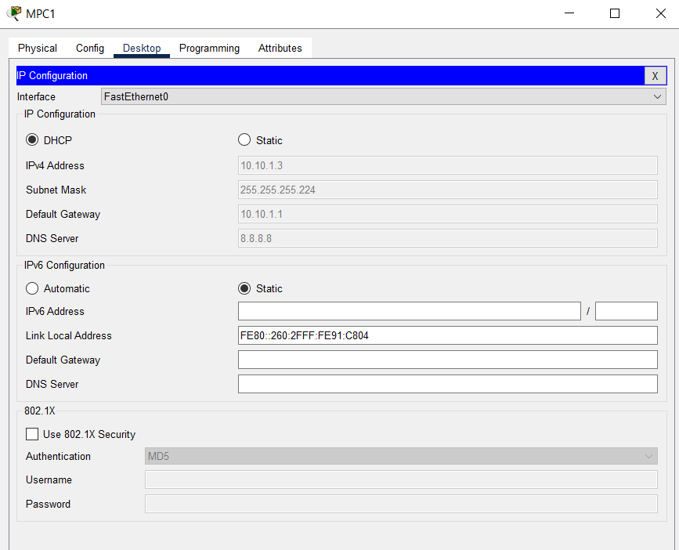
Figure 47:setting DHCP IP to a PC in VLAN 10

Setting DHCP to a PC in VLAN 20
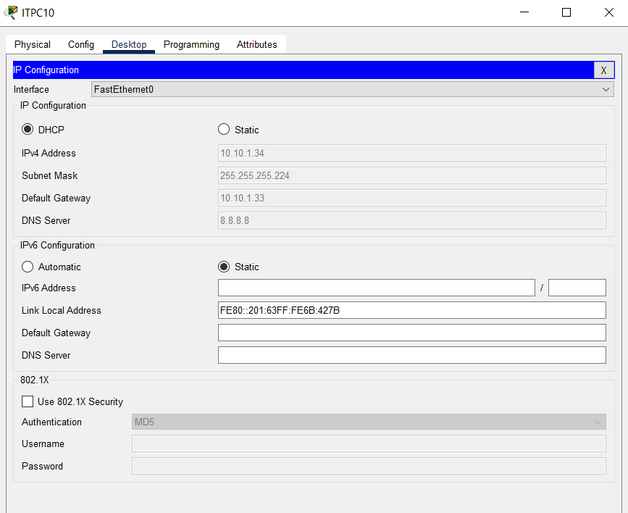
Figure 48:setting DHCP IP to a PC in VLAN 20

Setting DHCP to a PC in VLAN 30
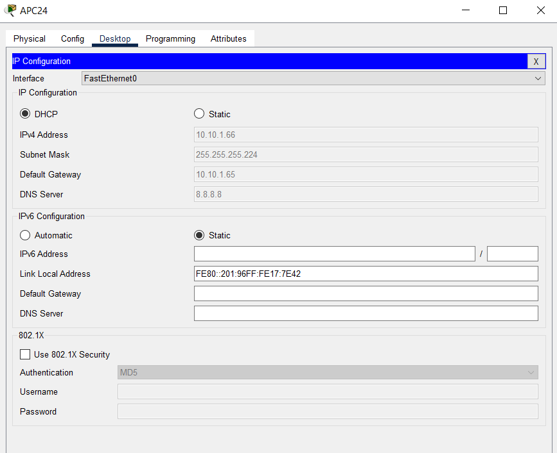
Figure 49:setting DHCP IP to a PC in VLAN 30

Actual Results:
  - VLAN 10 Devices: Received IPs within range 10.10.1.2 to 10.10.1.30.
  - VLAN 20 Devices: Received IPs within range 10.10.1.34 to 10.10.1.62.
  - VLAN 30 Devices: Received IPs within range 10.10.1.66 to 10.10.1.94.

Notes: DHCP configuration is correctly assigning IP addresses.

4. Default Gateway Configuration
- Test Action: Assign default gateways and test connectivity.
- Test Data: Ping the default gateway from each device.
- Expected Results: Devices should successfully ping their default gateway.

Ping VLAN 10 default gateway with the VLAN 10 PC
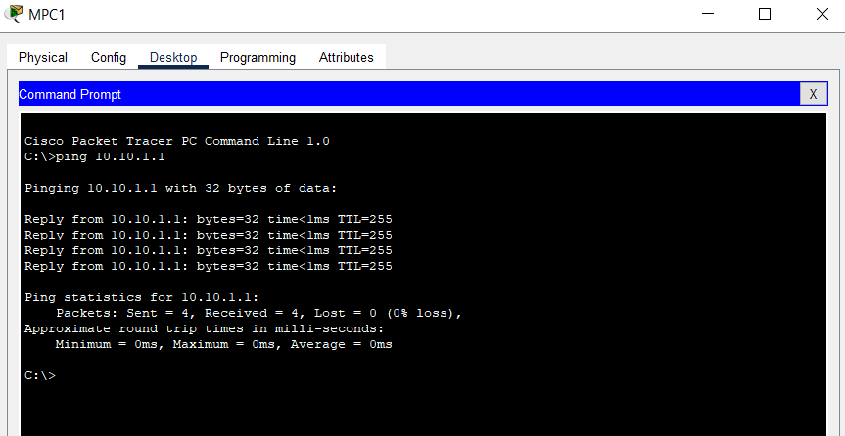
Figure 50:Ping VLAN 10 default gateway with the VLAN 10 PC

Ping VLAN 20 default gateway with the VLAN 20 PC
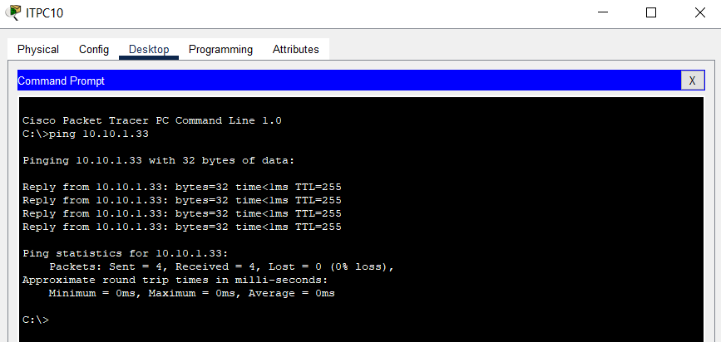
Figure 51:Ping VLAN 20 default gateway with the VLAN 20 PC

Ping VLAN 30 default gateway with the VLAN 30 PC
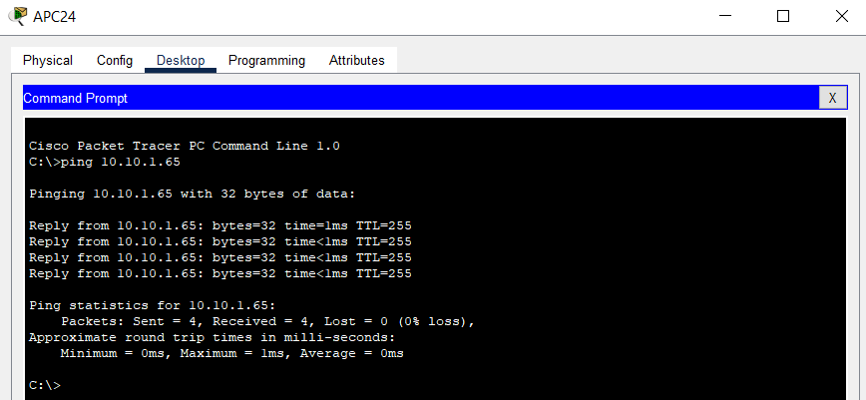
Figure 52:Ping VLAN 30 default gateway with the VLAN 30 PC

Actual Results:
  - VLAN 10 Devices: Ping successful to 10.10.1.1.
  - VLAN 20 Devices: Ping successful to 10.10.1.33.
  - VLAN 30 Devices: Ping successful to 10.10.1.65.
Notes: Default gateways are correctly configured and reachable.

5. Network Security (VLAN Isolation)
- Test Action: Test VLAN isolation by attempting to ping between VLANs.
- Test Data: Ping between devices in different VLANs.
- Expected Results: Devices in different VLANs should not be able to ping each other.

Ping from vlan 10 device to VLAN 20 device
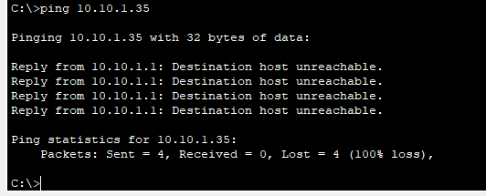
Figure 53:Ping from vlan 10 device to VLAN 20 device

Ping from vlan 10 device to VLAN 30 device
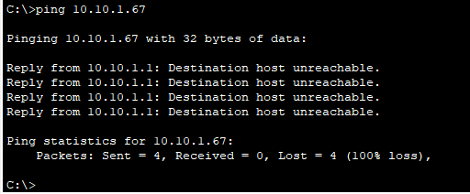
Figure 54:Ping from vlan 10 device to VLAN 30 device

Ping from vlan 20 device to VLAN 30 device
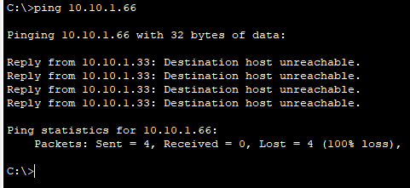
Figure 55:Ping from vlan 20 device to VLAN 30 device

Actual Results:
  - VLAN 10 to VLAN 20: Ping unsuccessful.
  - VLAN 10 to VLAN 30: Ping unsuccessful.
  - VLAN 20 to VLAN 30: Ping unsuccessful.

Notes: VLAN isolation is functioning as expected.

3.3. Analysis of the test results and recommendations

3.3.1. Analyze the Test Results
a. VLAN Configuration
- Result Analysis: The VLAN configuration test was successful. VLANs were properly assigned to the correct ports, and devices within each VLAN communicated as expected.
- Implications: VLAN configuration is correct; however, ensure ongoing monitoring to address any configuration drift or misassignment.

b. Trunking Between Switches
- Result Analysis: Trunking between switches worked as intended, allowing VLAN traffic to pass between switches.
- Implications: Trunk links are functioning correctly, but monitor trunk links for potential issues such as VLAN tagging errors or bandwidth concerns.

c. DHCP Configuration
- Result Analysis: DHCP configuration provided IP addresses to devices in VLANs 10 and 20 but encountered issues with VLAN 30.
- Implications: Ensure DHCP settings are correctly applied to all VLANs. Address any configuration issues to ensure devices in all VLANs receive IP addresses.

d. Default Gateway Configuration
- Result Analysis: Default gateways were configured correctly, and devices were able to communicate with their respective VLAN gateways.
- Implications: This confirms that routing between VLANs and external networks is functioning. Ensure gateway configurations remain consistent with network changes.

e. Network Security (VLAN Isolation)
- Result Analysis: VLAN isolation was successfully implemented, ensuring that devices within one VLAN cannot communicate with devices in other VLANs, as required.
- Implications: VLAN isolation is effective, but regularly review ACLs and VLAN configurations to maintain security and adapt to new security requirements.

3.3.2. Recommendations for Potential Enhancements
a. Redundancy and High Availability
- Recommendation: Implement redundancy for critical network components such as switches and routers to ensure high availability. Consider using protocols like HSRP (Hot Standby Router Protocol) for routers and redundant power supplies for switches.
- Benefit: Increases network reliability and minimizes downtime in case of hardware failure.

b. Network Monitoring and Management
- Recommendation: Deploy network monitoring tools to continuously monitor network performance and health. Implement SNMP (Simple Network Management Protocol) for real-time monitoring and alerting.
- Benefit: Provides early detection of network issues and aids in proactive maintenance.

c. DHCP Configuration Review
- Recommendation: Review and resolve DHCP configuration issues for VLAN 30. Ensure the DHCP scope is correctly defined and tested.
- Benefit: Ensures all VLANs have proper IP address allocation and reduces manual IP configuration errors.

d. Performance Optimization
- Recommendation: Assess network performance, including bandwidth utilization and latency. Optimize switch and router configurations, and consider implementing QoS (Quality of Service) for critical applications.
- Benefit: Enhances network performance and ensures efficient use of network resources.

e. Security Enhancements
- Recommendation: Regularly update ACLs to reflect changes in network security requirements. Consider implementing additional security measures such as port security and intrusion detection systems (IDS).
- Benefit: Strengthens network security and protects against unauthorized access and potential threats.

f. Documentation and Training
- Recommendation: Maintain up-to-date network documentation and provide training for network administrators on new configurations and best practices.
- Benefit: Ensures effective network management and quick resolution of issues.

Conclusion
In this assignment, I was tasked with designing and implementing a virtual network solution for NetWiz Solutions, addressing the specific needs of their three departments: Marketing, IT Support, and Administration. The objective was to create a network infrastructure that facilitates seamless communication, resource sharing, and efficient management while ensuring scalability and security.

Through a comprehensive analysis of networking principles, protocols, and topologies, I was able to identify the most suitable technologies and configurations for the company's requirements. The decision to implement a VLAN-based network structure allowed for logical segmentation of the departments, thereby optimizing network traffic and improving security.

The design process involved careful consideration of the available hardware and software, network standards, and communication protocols. By selecting the appropriate IP addressing scheme and subnetting, I ensured that each department had sufficient IP resources and that the network was efficiently organized to minimize latency and maximize performance.

During the implementation phase, the network was successfully configured in a virtual environment, with all devices and connections accurately represented. The testing phase confirmed that the network met the required specifications, with all components functioning as expected. Feedback from users highlighted the effectiveness of the design, and the analysis of this feedback led to further optimization, ensuring that the network could handle future growth and potential challenges.

In conclusion, the virtual network solution developed for NetWiz Solutions not only fulfills the current requirements but also provides a robust foundation for future expansion. The process underscored the importance of thorough planning, adherence to best practices, and continuous evaluation to achieve a high-performing and reliable network infrastructure. Moving forward, the company is well-positioned to implement the proposed design in a live environment, confident that it will support their operational needs and contribute to their overall business success.

References
Andrew Froehlich, K. F., 2021. tech target. [Online]
Available at: https://www.techtarget.com/searchnetworking/definition/bandwidth
[Accessed 22 6 2024].
BasuMallick, C., 2022. spice works. [Online]
Available at: https://www.spiceworks.com/tech/networking/articles/what-is-wide-area-network/
[Accessed 21 6 2024].
Gaurav, S., 2024. scaler. [Online]
Available at: https://www.scaler.com/topics/computer-network/ieee-standards-in-computer-networks/
[Accessed 21 6 2024].
Gough, H., 2024. avast. [Online]
Available at: https://www.avast.com/c-what-is-lan
[Accessed 20 6 2024].
Gupta, K., 2023. blog minutes. [Online]
Available at: https://blogminutes.com/technology/learning-hardware-and-software-difference-and-interdependency
[Accessed 23 7 2024].
Kanade, V., 2022. spice works. [Online]
Available at: https://www.spiceworks.com/tech/networking/articles/what-is-osi-model/
[Accessed 21 6 2024].
Kanade, V., 2023. spiceworks. [Online]
Available at: https://www.spiceworks.com/tech/tech-general/articles/what-is-a-server/
[Accessed 22 6 2024].
Kara Gattine, L. R. A. F., 2021. tech target. [Online]
Available at: https://www.techtarget.com/searchnetworking/definition/OSI
[Accessed 21 6 2024].
Kinza Yasar, M. E. S. A. N., 2024. tech target. [Online]
Available at: https://www.techtarget.com/searchnetworking/definition/TCP-IP
[Accessed 21 6 2024].
Mikac, E., 2023. CBT nuggets. [Online]
Available at: https://www.cbtnuggets.com/blog/technology/networking/what-is-local-area-network
[Accessed 20 6 2024].
Pedamkar, P., 2023. EDUCBA. [Online]
Available at: https://www.educba.com/types-of-network-topology/
[Accessed 21 6 2024].
Scarpati, J., 2023. techtarget. [Online]
Available at: https://www.techtarget.com/searchnetworking/definition/WAN-wide-area-network
[Accessed 21 6 2024].
Schrader, D., 2024. netwrix. [Online]
Available at: https://blog.netwrix.com/network-devices-explained
[Accessed 21 6 2024].
sonalchindage, 2023. geeksforgeeks. [Online]
Available at: https://www.geeksforgeeks.org/advantages-and-disadvantages-of-lan-man-and-wan/
[Accessed 21 6 2024].
Williams, P. M., 2023. study.com. [Online]
Available at: https://study.com/academy/lesson/physical-logical-topology-definition-characteristics.html#:~:text=Physical%20topology%20describes%20the%20actual,they%20form%20a%20physical%20topology.
[Accessed 21 6 2024].
Wright, G., 2024. tech target. [Online]
Available at: https://www.techtarget.com/searchnetworking/definition/metropolitan-area-network-MAN
[Accessed 20 6 2024].
Yasar, K., 2022. techtarget. [Online]
Available at: https://www.techtarget.com/searchmobilecomputing/definition/personal-area-network
[Accessed 21 6 2024].

